
2/16/22

MCRC
Board Member’s Handbook
2022 Edition



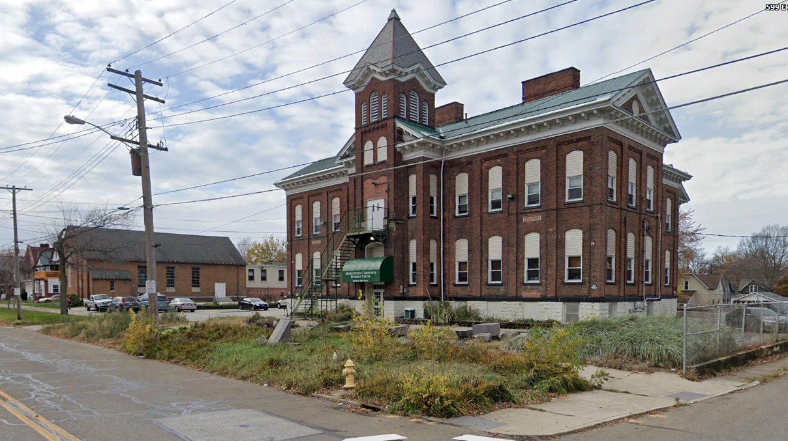
TABLE OF CONTENTS

I. Introduction
A. Board Roles and Responsibilities
B. The Basics of Board Membership

II. MCRC Basics
A. Who We Are
1. Size of the Organization
2. Agency History
B. Facilities
C. What We Do
1. Vision
2. Mission
3. What do those actually mean?
4. Do we bring refugees and immigrants into Erie?
D. How We Do It
1. Our Organization
2. Board of Directors
3. Employees
4. What happens when an immigrant walks in the door?
5. Our Programs
E. Funding Sources
1. Key Sources of Funds
2. Subsidiaries
3. Fundraising
F. Marketing/Outreach Programs
1. MCRC Noticias
2. Online presence and social media
3. Others?
G. Guide to Acronyms
H. Key MCRC Documents

III. What Board Members Need to Know
A. What a New Board Member Should Do
B. What Board Members Should NOT Do
C. Composition of the Board
D. Responsibilities and Legal Issues
E. Meetings
F. Committees
G. Officers, Their Duties and Terms
H. Financial Issues
1. Fiscal year
2. General overview of MCRC’s finances
3. Audits
4. Annual tax return
5. Endowment
6. Does our nonprofit status mean we can’t make a “profit”?
7. Property purchases
I. Personnel Issues

J. Donations and Volunteers
1. Donations
2. Volunteers

IV. General Information on the Immigration Process and Refugee Issues
A. Who Is a Citizen?
B. Immigrants, Refugees, Asylees and More
C. How the U.S. Immigration System Works
D. Other Key Erie Organizations Dealing with Immigrants

V. Resources
A. Erie-Related
B. Immigration-Related
C. Useful Websites and Organizations

Appendices
Appendix 1: Bylaws of MCRC
Bylaws Appendix A: Timeline
Bylaws Appendix B: MCRC Non-profit Board Member Expectations
Bylaws Appendix C: MCRC Conflict of Interest Policy
Appendix 2: Executive Director Position Description
Appendix 3: Process and Timeline for the Annual Review of the Executive Director

1/16/22

MCRC Board Member’s Handbook

I. Introduction
You’ve been invited to become a member of the Board of Directors of the Multicultural Community Resource Center. Congratulations! Now what??
This Handbook is intended to tell you “everything” (i.e., some things) you need to know about being an MCRC Board member. But before we get into the details, let’s start by reviewing what it means to be a Board member of a nonprofit organization in general. Here is some information on that topic from the National Council of Nonprofits. Much more information on these topics is available at their website (https://www.councilofnonprofits.org/tools-resources/board-roles-and-responsibilities), and we encourage you to explore it after you’ve been through this Handbook.

A. Board Roles and Responsibilities
Board members are the fiduciaries who steer the organization towards a sustainable future by adopting sound, ethical, and legal governance and financial management policies, as well as by making sure the nonprofit has adequate resources to advance its mission.
One of the most important responsibilities for many boards is to hire and set the compensation of a talented CEO/executive director to run the day-to-day management activities of the organization. When there are paid staff in place, rather than steer the boat by managing day-to-day operations, board members provide foresight, oversight, and insight: think of them as up in the crow's nest scanning the horizon for signs of storms or rainbows to explore, perhaps with a pot of gold at the end! Yes, board members--your role as stewards of the nonprofits DOES involve fundraising. And another important role board members play is to be advocates for the nonprofit's mission.

B. The Basics of Board Membership
What’s the role of the board of directors of a nonprofit corporation? Just as for any corporation, the board of directors of a nonprofit has three primary legal duties known as the “duty of care,” “duty of loyalty,” and “duty of obedience.”
1) Duty of Care: Take care of the nonprofit by ensuring prudent use of all assets, including facility, people, and good will;
2) Duty of Loyalty: Ensure that the nonprofit's activities and transactions are, first and foremost, advancing its mission; Recognize and disclose conflicts of interest; Make decisions that are in the best interest of the nonprofit corporation, not in the best interest of the individual board member (or any other individual or for-profit entity).
3) Duty of Obedience: Ensure that the nonprofit obeys applicable laws and regulations; follows its own bylaws; and that the nonprofit adheres to its stated corporate purposes/mission.
However, a board of directors does not exist solely to fulfill legal duties and serve as a fiduciary of the organization’s assets. Board members also play very significant roles providing guidance to nonprofits by contributing to the organization’s culture, strategic focus, effectiveness, and financial sustainability, as well as serving as ambassadors and advocates. Beyond fulfilling legal duties, board members can be important resources for the organization in multiple ways.
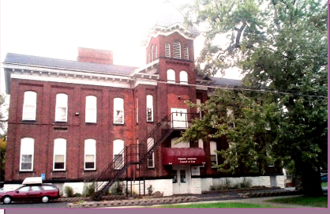
II. MCRC Basics

A. Who We Are
Name: Multicultural Community Resource Center, or MCRC
Address: 554 East 10th Street Erie, PA 16503
Phone: (814) 455-0212 Fax: (814) 453-2363
Email: MCRC@mcrcerie.org
Individuals at MCRC have their own email addresses, of course.
Website: http://www.mcrcerie.org
Facebook: https://www.facebook.com/mcrceriepa
Twitter: https://twitter.com/mcrc_erie
Hours: Monday - Friday, 8:30 AM - 4:30 PM
Employer Identification Number (EIN): 25-1271293
This is the federal government’s official ID number that is unique for each organization, analogous to an individual’s Social Security number.
IRS tax status: 501(c)(3)
This is the section of the US Code which defines a “public charity”, the type of nonprofit organization that MCRC is. Among other things, this status makes (most) donations to MCRC tax-deductible for federal income tax purposes. It also limits the kinds of activities in which we can engage if we are to retain our public charity status. For example, we are prohibited from supporting political candidates.

Include IRS Form 1023 that originally requested tax exempt status
https://www.irs.gov/charities-non-profits/frequently-asked-questions-about-form-1023

1. Size of the Organization
-Number of clients served annually:
-Number of employees: the number varies. In January 2022 it was approximately 50: 26 full-time, about 20 part-time, and several per diem employees.
-Number of buildings: three, plus a rented office at the John E. Horan Garden Apartments (JEHGA). See the “Facilities” section below for details..
-Number of programs: the number varies depending on client needs and funding availability. There are about 20 programs in January 2022.
-Annual budget: about $2.3 million annually in 2021-22.
-Number of vehicles
-What else?

2. Agency History
On April 29, 1975, The Hispanic American Council was incorporated as a nonprofit organization. The Council was first located at the Spanish Apostolate, an Erie Diocesan Mission Office at 611 West 17th Street. The Council started with no administrative funds and operated with volunteers and two paid staff.
In September of 2009, the organization’s name was changed to the Multicultural Community Resource Center to more accurately reflect the diverse and ever-increasing population served. Today MCRC employs more than 50 individuals and is located in the old Penn Schoolhouse at 554 East 10th Street in Erie. Since the building was erected in 1880, it is gradually being refurbished to its original architectural prominence as a center of learning in Erie.

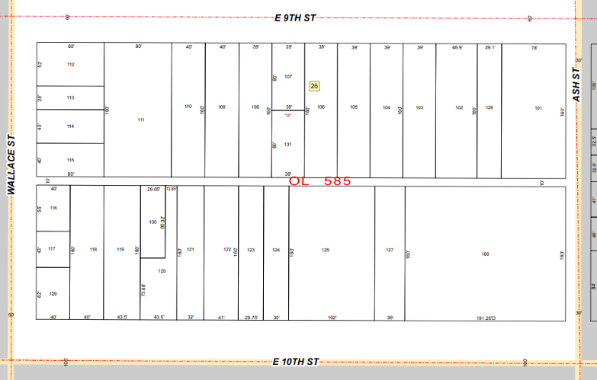
B. Facilities

Main campus: Comprised of four parcels at East 10th and Ash Streets in the City of Erie.
Area: (329.25’ x 160’) + (78’ x 160’) = 65,160 sq ft, or 1.4959 acres.
A 10’ wide alley runs east-west behind the main properties.

Note: much of the information here is from the Erie County Assessment Office at https://eriecountypa.gov/departments/assessment/.

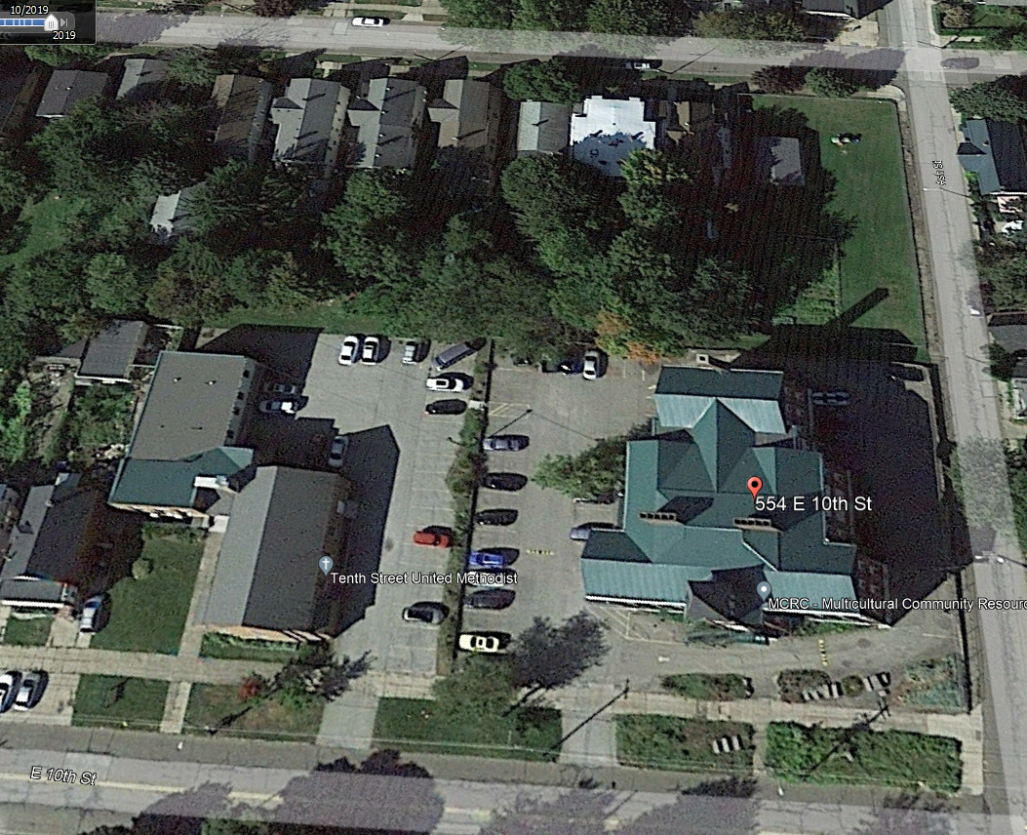
Images are from Google Earth, October 2019.
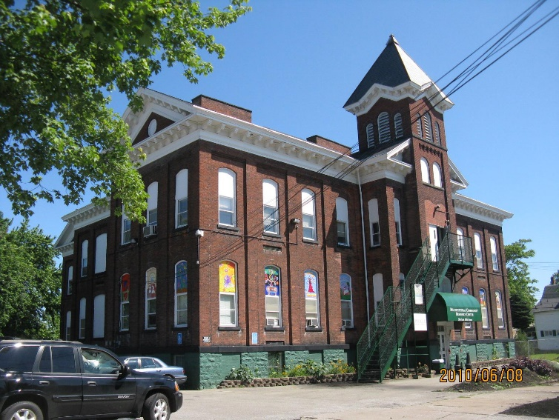
Main building: 554 East 10th Street
The former Penn School built in 1881 and 1896.
Erie County Parcel Number: 15020026010000
Lot: 193.25’ x 160’ = 30,920 sq ft, 0.7025 acres

Building: 3 floors including basement, 23,559 sq ft
Assessed value: $305,800
Floor plan: 7,853 sq ft per floor, three floors.

The main building houses administrative offices, the daycare center, classrooms and meeting rooms… (WHAT ELSE?)

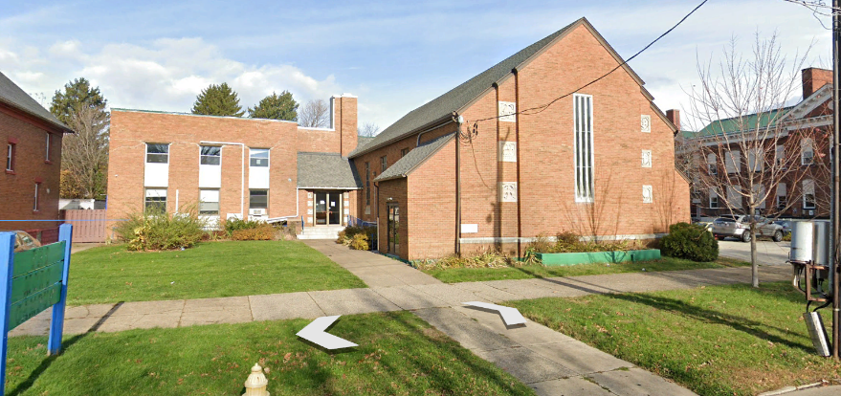
Annex: 538-40 East 10th Street
The former 10th Street United Methodist Church and school, built 1949.
Erie County Parcel Number: 15020026012500
Lot: 102’ x 160’ = 16,320 sq ft, 0.3747 acres
Building(s): Church 3,200 sq ft, school 8,300; total 11,500 sq ft.
Assessed value: $120,000
Bought 12/20/2012 for $72,000.

The Annex houses:
-Ethnic Senior Program
-Civics Class for those seeking citizenship
-Sign Language classes
-Health Clinics
-Various Educational Clinics
-Commercial kitchen?

Annex parking lot: 542-44 East 10th Street
Erie County Parcel Number: 15020026012700
Lot: 36’ x 160’ = 5,760, 0.1322 acres
Building(s): Church 3,200, school 8,300; total 11,500 sq ft.
Assessed value: $10,300
Bought 12/20/2012 as part of purchase of the church and school.


Picnic lot: Southwest corner of East 9th and Ash Streets
Erie County Parcel Number: 15020026010100
Lot: 78’ x 160’ = 12,480 sq ft or 0.2865 acres
Structure: covered pavilion 20’ x 30’, total 600 sq ft. Built 2019.
Assessed value: $18,900

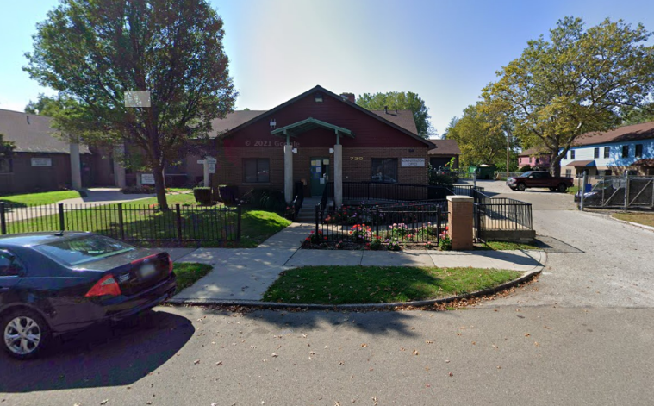
John E. Horan Garden Apartments Learning Center (JEHGA)
MCRC maintains an office in the John E. Horan Garden Apartments at 730 Tacoma Rd;
Phone: (814) 454-1266.
The MCRC Family Support Center Services at the JEHGA Learning Center is a community based family support program designed to assist residents of the John E. Horan Garden Apartments and Bird Drive apartments, as well as residents of those neighborhoods. The Family Support Center Services provides a wrap-around approach and includes Family Support, Employment Services, and Adult Education Opportunities.

C. What We Do

1. Vision: Hispanic and other ethnic minorities will experience acceptance, respect, independence, and self-sufficiency in our community.

2. Mission: To facilitate the educational, social, political, and economic progress of the communities we serve. We will work to break down cultural barriers due to language, appearance, or ethnic traditions. We will actively promote and advocate the development, empowerment, and advancement of all people while preserving their cultural identity. We will work to educate the community to value diversity.

3. What do those actually mean?
The Multicultural Community Resource Center provides a variety of educational and employment programs to the Immigrant and Refugee populations in Erie in a customer-focused manner. The service needs of the clients are of prime importance. All services promote client self-sufficiency and improved economic, physical, and/or social wellbeing.

4. Do we bring refugees and immigrants into Erie?
No. That is done by two other organizations in Erie:
- The U.S. Committee for Refugees and Immigrants Erie Field Office (formerly the International Institute of Erie): https://refugees.org/uscri-erie/
-Catholic Charities of Erie, Counselling and Adoption, Refugee Resettlement program
https://www.cccas.org/refugee-resettlement/
After refugees and immigrants arrive in Erie, MCRC helps them on their path to self-sufficiency as new Americans, as clients of our many programs.

D. How We Do It

1. Our Organization
See next page for our Organization Chart.

2. Board of Directors
Section III has all the necessary details about the Board of Directors.
Members of the Board: see the latest Board Roster. In January 2022, the Board included:

President: Michael Burns
Vice-President: Alice Edwards, PhD
Secretary/Treasurer: Donald Nicholson
Carolyn Baugh, PhD
John Blakeslee
Ashutosh Deshmukh, PhD
Elizabeth Edwards
Joseph Kumer
James Kurre, PhD
Julio Quezada
Robert Zaruta

3. Employees
Leadership team:
- Katie Kretz, Executive Director
-Srdan Ninkovic, Associate Director of Operations
-Matthew Platz, Director of Refugee Social Services
-Melissa Novatnack, Director of Childcare
-Deborah Pazmino, Director of Immigration
-Eddie Ocazio, JEHGA Director
Other employees: about 45-50 people (plus per diems) in total, in January 2022.

Add a comment on how MCRC hires, especially about diversity and hiring from the immigrant community.

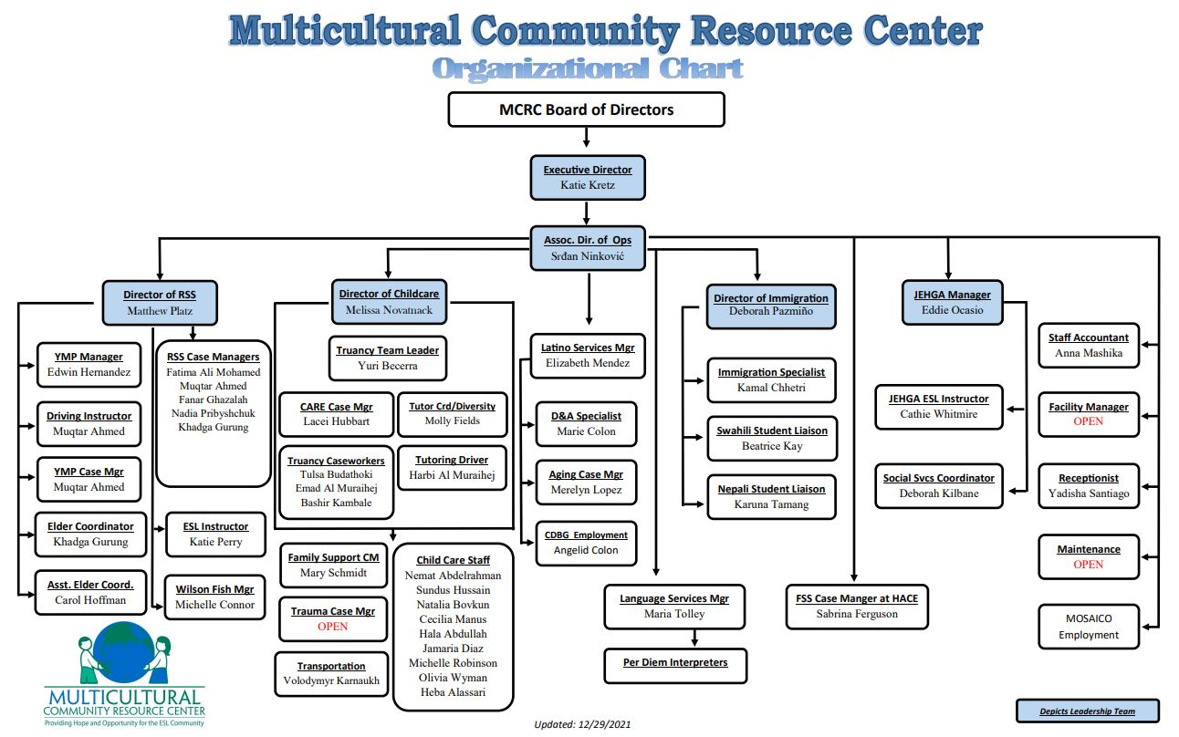

4. What happens when an immigrant walks in the door?
How do we actually help them? What’s the process?

5. Our Programs
-ranked by importance / $amount / # of clients?

IMMIGRATION SERVICES (460 unduplicated clients in 2021)
Immigration Services are offered to immigrants and their families residing in the Erie area. An accredited representative, recognized by the Immigration Board of Appeals, works on-site to assist in services provided. Referrals to immigration lawyers are made as needed. Modest fees are charged and services are rendered by appointment. Services include immigration counseling and assistance with applications for permanent residency, citizenship, travel documents, work authorizations, fiancé visas, petitions for sponsorship, and other immigration forms. Notary services are also available.

REFUGEE SUPPORT SERVICES (RSS) (217 clients in Oct 2021)
Refugees or Asylees who have lived less than five years in America are eligible for all services provided through the Refugee Social Services program. Those who have lived in the U.S. more than five years are limited to translation and case management services. On occasion, the state has waived the five-year limit.
SERVICES

Pre-screening of program participants
Vocational assessment of refugee skills
Matching refugee skills to an appropriate pre-employment class
Computer classes
Driving simulation classes
On-site assistance with hiring
Long term follow-up support with employers
Interpretation and translation skills
Job coaching support
Referral services
Youth Mentoring Program (15 clients in Feb 2022)
Refugee School Impact Program, children from11-21, up to 25 clients

LATINO SERVICES
MCRC’s services are geared toward improving the lives of Erie’s immigrant and refugee residents. We realize Erie’s immigrants and refugees are a diverse group and services are custom tailored to meet those needs. MCRC’s bilingual, bicultural professional staff is from Colombia, Venezuela, Mexico, and Puerto Rico. All services are provided in Spanish or English as necessary. Services are inclusive and aim to cover a variety of needs. Overall needs addressed and services that meet those needs include:
Case Management – Adult. Case Management services target low-income, limited-English speaking persons living within Erie County. Typically, the process involves educating clients as to the availability of community resources that may meet their needs and helping the client access those resources. This may include, but is not limited to, making referrals to service providers, making phone calls and reading correspondence. Meetings may take place over the telephone, at the agency, or with the clients at their homes. Assistance is offered on an as-needed or on-going basis to eligible clients.
Aging. (84 clients in Feb 2022)
Seniors (60 and above) are a growing segment of the Erie Hispanic community, but many gaps exist in the service provision to this population. This program provides specific case management, addressing the issues common to this population. All seniors are enrolled with the Area Agency on Aging to determine additional eligibility for services, such as Meals on Wheels, personal care, or nursing home care. Emphasis will be placed on enrolling clients in the PACE/PACENET program and/or Medicare and eligible supplements. Finally, this program will seek to connect seniors with local senior centers that provide necessary recreational programs.
Drug and Alcohol program. (67 clients in Feb 2022)
CDBG (52 clients in Feb 2022)

EDUCATION
The Education Department of MCRC offers the following classes:

-English as a Second Language (ESL)
-Employment readiness
-Workforce instruction
-Basic computer instruction

English as a Second Language classes include five levels of instruction, from phonics to advanced. Our ESL students attend classes four to five days a week, depending on the time of day. Immigrants and refugees interested in attending GED(c) preparation classes, can do so twice a week, in the evening. All students are tested and carefully placed in level-appropriate classes. All classes are free of charge and are funded through the PA Department of Education by the Bureau of Post-Secondary and Adult Education.
Individualized classes in specific areas can be prepared for groups or employers as requested.

TRUANCY PREVENTION & C.A.R.E. PROGRAMS
Truancy Prevention offers case management, counseling, and student workshops for Latino/Hispanic and ESL/Refugee students who are truant or who are on the path to becoming truant. Truancy Prevention works with the schools, family, and social service agencies to help the student understand the important role school attendance plays in reaching their goals. Referrals can be made by schools, social service agencies, the Erie County Office of Children and Youth (E.C.O.C.Y.), or the district courts.
Community Assistance for Refugee Enrichment (C.A.R.E.) offers case management, counseling, and student workshops to Refugee/Immigrant and ESL/Refugee children who are reported to E.C.O.C.Y. and are at risk of out-of-home placement. Referrals are made from E.C.O.C.Y. to C.A.R.E. when there are concerns regarding neglect, discipline problems, and/or lack of parenting skills, which are common factors associated with truancy.
Truancy Prevention and C.A.R.E. programs also offer classes for parents who are interested in understanding the laws and expectations of Pennsylvania and the Erie School District in regards to attendance and truancy. Classes are provided in a different language each week and are open to any Latino/Hispanic or ESL/Refugee parent.

DAYCARE (60 children in Feb 2022)
Care and early education is provided by our STAR 3 facility for children ages 6 weeks through 12 years. We offer both half-day and full-day placements as well as transportation from area schools for our After School Care Program. Our summer school age program boasts field trips to local establishments and area parks. As part of our programming, we offer nutritious meals and snacks at no extra charge to our families while recognizing the cultural practices of the families we serve.
Hours of Operation: Monday through Friday 6:00 AM to 6:00 PM
Payment Options: To meet the wide range of financial needs of our families, we offer a variety of payment options. Families are encouraged to apply for funding through Child Care Information Services (CCIS). We also offer private pay rates as well as a sliding scale option with proof of income.

LANGUAGE SERVICES
Accurate Communication Language Services provide professional interpretation of multiple languages in a variety of settings for emergency and scheduled appointments. Services include verbal interpretation in legal, medical, and social settings. Every employee has received special training in language interpretation. Services are provided on a fee-for-service basis. Translation of business forms, letters, manuals, and other documents are also provided. Services are offered 24 hours a day, 7 days a week, with emergency on-call services available. Languages include, but are not limited to: Spanish, Bosnian, Russian, Ukrainian, Arabic, Vietnamese, Swahili, and Burmese.

EMPLOYMENT
Refugee Support Services (RSS) and Targeted Assistance Grant (TAG) are programs designed to locate job opportunities for the refugee communities in Metropolitan Erie. Refugees have left their homeland because of political or religious persecution, often without warning or preparation. They possess many of the skills needed in the US but need help in their search for employment. MCRC assists them in employment to gain the self-sufficiency they desire for themselves and their families.
Employment areas:

General Labor / Light Labor
Housekeeping / Care Giving
Technical / Mechanical
Plastic Shops / Machine Shops
Food Services / Restaurants
Construction / Carpentry
Assembly / Packing

MCRC ANNEX
The MCRC Annex is a community center devoted to celebrating diversity, culture, and community integration throughout the Erie area. The Annex Building is a place rich in culture and diversity, with services tailored to meet the social, economic, and environmental needs of each ethnic population that is served.
PROGRAMS AND SERVICES
Ethnic Senior Program – Drop in Center for refugee seniors age 60 and over. Program runs Tuesday through Thursday 9am-Noon in the basement of the Annex. Variety of optional classes offered throughout program. (20 clients in Feb 2022)
Civics Class – Citizenship class for people who have less than one year before they are eligible to take their citizenship test. Class is taught every Tuesday and Thursday from 11am – 12:15pm.
Sign Language class – Program to teach ASL to our deaf and hard of hearing clients. Runs every Monday, Wednesday, and Friday from 10am-11:30am. Program is run by community volunteers, open to only those who have hearing or speaking concerns.
Health Clinics – Various health and wellness programs run throughout the year. Programs can include flu shot clinics, heath education sessions, and a variety of screenings.
Various Educational Clinics – Programs are run throughout the year focusing on a variety of topics. Some programs target refugee and immigrant communities while others are targeted towards educating the professional communities.

JOHN E. HORAN GARDEN APARTMENTS LEARNING CENTER (JEHGA)
The MCRC Family Support Center Services at the JEHGA Learning Center is a community based family support program designed to assist residents of the John E. Horan Garden Apartments and Bird Drive apartments, as well as residents of those neighborhoods. The Family Support Center Services provides a wrap-around approach and includes Family Support, Employment Services, and Adult Education Opportunities.
Program Services: Family Support Services are offered to help families make critical connections to other families and resources in their neighborhoods and the Erie Community. Through employment and education services along with social service referrals, staff help eliminate barriers, build supportive relationships, and attain personal goals.
A COMPUTER LAB is available to all participants and on a drop-in basis for residents. Phone, internet connection, printing, copying, and faxing services are available free of charge.
EMPLOYMENT SERVICES - Our Employment Coordinator offers career counseling, guided job search and job placement services including resume building, assistance with completing job applications, mock interviews, and workplace computer skills. Participants can work one on one or in small group workshops. Our connections to the MCRC also allows us to assist those with limited English, and work with employers who look to provide employment opportunities for non-native English speakers. A Job Postings board is updated regularly with current job postings and training opportunities.
EDUCATION SERVICES include:
GED Preparation -- Basic adult education assessment and classes designed to help the individual attain their high school equivalency diploma in addition to individual study support for content area tests. (7 students in Feb 2022)
ESL Classes – Classes designed to assist participants with improving their basic English language, verbal and reading comprehension skills. Classes are offered at various levels including: Beginner ESL, Advanced ESL and Family ESL. (31 students in Feb 2022)
Citizenship Preparation- Independent study areas, one-on-one preparation and small group classes are offered to help students prepare for their Citizenship Interview and Test. (7 students in Feb 2022)
Career Exploration and Development – Assistance in identifying appropriate and meaningful career opportunities and completing a goal plan to transition to the workforce or further education/training. Assistance with FAFSA and scholarship applications available.
Computer Literacy – Classes will assist the participant to develop the basic computer skills necessary for many of the employment opportunities available in Erie. Interest based classes such as PowerPoint, EXCEL, Intro to Internet and Print Shop are offered as well.
College Exploration and Preparation – Participants interested in pursuing college-level study will be assisted with identifying post-secondary learning opportunities and developing a plan to engage higher education. Adult students can also receive remediation of Math, Reading, Writing and Study Skills in order to become more confident entering (or returning to) the post-secondary setting. Staff will assist with applying for scholarships and internships.
FAMILY SUPPORT SERVICES; A social service case worker will engage with each participant to assure progress on the residents’ plan and assist with providing the support needed to actively pursue the participant’s goals. A wrap-around approach will be encouraged in order to fully support our participants.
Referrals to social services: A social service manager will help identify barriers and assist residents in accessing supportive services in the neighborhood and the Erie community.
Housekeeping/homemaking services: One-on-one and group support available, by referral, from the Housing Manager on topics such as: Cooking and Nutrition, Wellness and Parenting, Cleaning and Housekeeping Techniques, Budget and Money Management, De-cluttering and Organizing, etc.
Community building events: Holiday Events, Make and Take Craft Activities, Empowerment Groups, Summer Programming, etc. sponsored by HACE and MCRC.

MOSAICO https://www.mosaicoerie.com/
MOSAICO Employment Services Inc. is a totally-owned, for-profit subsidiary of the MCRC. Established in 2007, MOSAICO is designed to foster long-term relationships with employers by supplying qualified, motivated employees while providing language and cultural diversity supportive services to Associates and business partners. It specializes in the English-as-a-second-language community and assists about 600 clients per year. It is currently located in the Neighborhood Partnership Center at 254 E 10th Street in Erie. Phone: (814) 464-0970.

DIVERSITY TRAINING
The Diversity Training Program is part of our mission to inform and educate the Community of Erie to value diversity. Since 1998, MCRC has had the privilege of working with people from all over the world, and in providing services to some very diverse populations, we have acquired considerable knowledge and skills that have enabled us to create a comprehensive Diversity Training Program with a wide variety of workshops options. This training is available to all organizations in the Greater Erie area who are interested in:
-Promoting a diverse workplace
-Increasing their knowledge base in the areas of Cultural Sensitivity, Awareness and Competence
-Learning more about the different new populations that are starting to call Erie their home
Our Diversity Training Catalog lists the various course options in this program and provides detailed descriptions of the curriculum/content for each of these courses. The catalog also describes the variety of ways in which the workshops may be presented.

TRANSPORTATION
The MCRC offers limited transportation services to adult clients. The MCRC has developed a route system that runs on both the eastside and the westside of Erie at various times throughout the day. Timing is based on the clients’ class or work schedule. This service is provided to adults who attend classes and the children who are placed in daycare. It also transports childcare children daily, to and from the local elementary schools. This program is funded through private pay and the Department of Public Welfare. Transportation is also available to first shift worksites to the westside of Erie for a fee.

NOTARY SERVICE
Services provided for a fee.

E. Funding Sources
1. Key Sources of Funds. (Amounts in parentheses are from our 2018 990 tax return.)
-Grants ($1,290,661)
-Contracts (?? Part of Grants above?)
-Fees for services rendered ($743,560). Includes daycare, interpretation services, immigration fees, education and employment services and notary fees.
-Fundraising ($38,993)
-Donations (?? Part of Grants above for $20,921?)
-Investment income ($3,874)
-Mosaico Employment Services (for-profit subsidiary) (??)

-Ranked by importance / $amount / # of clients?

2. Subsidiaries
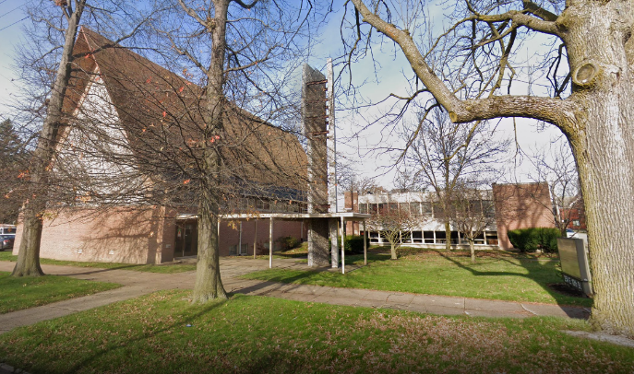
MOSAICO Employment Services Inc. (https://www.mosaicoerie.com/) is a totally-owned, for-profit subsidiary of the MCRC. It was established in 2007 to help MCRC’s clients achieve self-sufficiency, and also to provide another revenue source for MCRC. It helps local firms find qualified, motivated employees while providing language and cultural diversity supportive services to the agency’s clients and business partners. While MOSAICO specializes in the English-as-a-second-language community, it serves anyone from the Erie area, and assists about 600 clients per year. It is currently located in the Neighborhood Partnership Center at 254 E 10th Street in Erie. Phone: (814) 464-0970.

3. Fundraising
In 2019-20 (through March 2020), about $35,000 was generated through various fund-raising efforts, about 2.6% of total MCRC revenues. (NOTE: get full year amounts from recent year-end reports.)
-Key fundraisers
-Erie Gives: MCRC participates in the Erie Community Foundation’s “Erie Gives” day in early August. Donations made that day are augmented by large gifts from ECF and several corporations in town. Appeals are made through social media. In 2021 we received $7,749 (Oct ‘21 Minutes say $8,320) in total from this event.
-Annual Appeal: This has traditionally been in the form of a letter sent out by the Executive Director around the December holidays. In 2019 it raised about $4,700.
-Comedy Night at Kellar’s/Jr’s: organized by the Board, this evening (lately in November) at Kellar’s (formerly Jr’s Comedy Club) raises money on each ticket we sell, and also through an extensive basket raffle. It also gives MCRC folks a chance to have a night out together. In 2021 we sold 101 tickets and netted $1,217 in total.
-Golf Outing: MCRC hosted eight golf outings until Covid put it on hiatus in 2020. It typically took place in early September at the Lake Shore Country Club and included 18 holes and a banquet. It raised funds through golfer registrations, sponsorships, and fundraisers at the event such as paying for mulligans and skins, a basket raffle, and 50/50. In 2019, it grossed over $27,000. BUT WHAT WAS THE NET?
-Trivia Night/Citizenship Test: this event started as a Citizenship Test quiz, but then morphed into a trivia competition focusing on issues related to American and Erie history and culture, typically in April. It raised money through sponsorships, team registrations and a basket raffle. Last held 2019 at Erie Downs, it raised about $4,000 with Erie Downs contributing all the food. It was another victim of Covid.
-The Highmark Walk. A team from MCRC has participated in this event sometimes in the past, but not recently. In 2017 it raised $2,500.
-Angel Tree: The daycare program sets up the Angel Tree in the front lobby in December, with “ornaments” with the names of children from the program. People take an ornament and buy a gift of $10-$15 for that child and bring it in unwrapped. This is not actually a “fundraiser” for MCRC since it is for the benefit of the kids, not MCRC itself.


F. Marketing/Outreach Programs
1. MCRC Noticias
This was the monthly newsletter of MCRC than ran for about nine years, through 2019. It was distributed via email. Currently inactive.

2. Online presence and social media
-Website: http://www.mcrcerie.org
-Facebook: https://www.facebook.com/mcrceriepa
-Twitter: https://twitter.com/mcrc_erie

3. Others?

G. Guide to Acronyms

ACLS: Accurate Communication Language Services, MCRC’s interpretation/translation program.
ASL: American Sign Language.
CARE: Community Assistance for Refugee Enrichment. An MCRC program.
CCIS: Child Care Information Services. A program of the Office of Child Development and Early Learning of the PA Department of Human Services that assists working families with the cost of child care and provides specialized resource and referral service that assists families with locating state licensed /regulated child care providers and offers parent education to help parents make an informed decision regarding their child care selection. https://www.pa211.org/agency/8585/10092/
CDBG: Community Development Block Grant, a HUD program: “to build stronger and more resilient communities.” https://www.hudexchange.info/programs/cdbg/
CM: Case Manager.
D&A: Drug and Alcohol.
DVPAP: Domestic Violence Prevention and Advocacy Program, an MCRC program. https://www.dhs.pa.gov/refugeesinpa/Documents/MCRC%20Domestic%20Violence%20Prevention%20and%20Advocacy%20Program.pdf
ECOCY: Erie County Office of Children and Youth. https://eriecountypa.gov/departments/human-services/children-and-youth/
ESL: English as a Second Language.
FAFSA: Free Application for Federal Student Aid. https://studentaid.gov/h/apply-for-aid/fafsa
FSS: Family Support Services, part of JEHGA activities.
HACE: Housing Authority of the City of Erie https://www.hace.org/.
GECAC: Greater Erie Community Action Committee. https://www.gecac.org/
In order to reduce poverty in its community, a Community Action Agency works to better focus available local, state, federal, and private resources to assist low-income individuals and families to acquire useful skills and knowledge, to gain access to new opportunities, and to achieve economic self-sufficiency. GECAC has its roots in LBJ’s Great Society programs, and its funding comes from the Block Grant system. Cf: CDBG.
JEHGA: John E. Horan Garden Apartments. A housing development of the Housing Authority of the City of Erie, at Franklin Avenue and Tacoma Road. MCRC has an office there, the Horan Learning Center.
OCY: Erie County Office of Children and Youth https://eriecountypa.gov/departments/human-services/children-and-youth/.
RSS: Refugee Support Services. An MCRC program. Sometimes: Refugee Social Services.
TAG: Targeted Assistance Grant.
USCIS : U.S. Citizenship and Immigration Services. The official government agency that oversees lawful immigration to the United States. https://www.uscis.gov/
USCRI: U.S. Committee for Refugees and Immigrants. This is a 501(c)(3) public charity whose mission is: “to protect the rights and address the needs of persons in forced or voluntary migration worldwide and support their transition to a dignified life.” In Erie, the International Institute of Erie is a partner of USCRI and brings immigrants to the area. https://refugees.org/

H. Key MCRC Documents
(There are probably too many and they’re too long to actually include them all in the Handbook, but e-copies could be provided on a flash drive or alternative media, or in a secure link on the MCRC website for the Board.)

-Annual Report. The Bylaws require that MCRC prepare an annual report for the Board within sixty days of the annual audit that details information about assets liabilities, revenues, expenses, etc. (XI.2)
-Articles of Incorporation
-29 April 1975 Articles Of Incorporation-Non-Profit 1 (Hispanic American Council, MCRC’s predecessor)
-25 June 2009 Articles Of Amendment-Nonprofit 2 (MCRC)
-Audit and opinion letter. The Bylaws require an annual audit (XI.2) and Board Members have a right to see the audit and the audit letter/opinion (VIII.2).
-Bylaws (Included as Appendix 1 below.) This is the crucial document that defines how MCRC operates. The Board is responsible for ensuring that the organization follows its Bylaws, and for updating them as necessary.
-Executive Director Position Description. Included as Appendix 2 below.
-IRS Form 1023 (or info about it?) that originally requested tax exempt status?
-IRS 990. MCRC is required by law to file an annual tax return with the Internal Revenue Service. The form 990 is the equivalent for nonprofits of an individual’s form 1040. Since we are a public charity, anyone can request a copy of our 990 for the past three years. There is a link on our website to a 990, but it is currently out of date. Recent copies can be found online at the IRS website: https://apps.irs.gov/app/eos/allSearch. Enter MCRC’s Employer ID Number (25-1271293) to get access to our recent returns.
-Policy Manual/Employee Handbook. The name is descriptive. About 114 pages.
-Process and timeline for the annual review of the Executive Director. Included as Appendix 3 below.

-What Others?…
III. What Board Members Need to Know
Here is a brief overview of many important items. Items in parentheses are Bylaw sections; refer to the Bylaws (in Appendix 1 below) for full details.

A. What a New Board Member Should Do
1) Read Appendix B of the Bylaws: “MCRC Non-Profit Board Member Expectations.” Consider them carefully! If you cannot meet these expectations have a serious conversation with the Board President immediately.
2) Read this manual!
2) Ask the Executive Director or Board President about getting a tour of the MCRC facilities.
3) Consider what talents or gifts you have that can help MCRC in its mission, then volunteer to do whatever is most appropriate for you. That may mean serving on a committee, participating in a project or program, helping publicize MCRC, and/or making donations, among other things.
4) Participate in MCRC events and help to make them successful by bringing people, securing donated items or baskets, publicizing them on social media, etc.
5) Donate to the extent that you are able. This includes making a donation during Erie Gives, which will be partially matched by the Erie Community Foundation and others. There will be other opportunities to donate during the year.

B. What Board Members Should NOT Do
-You should NOT insert yourself into the day-to-day operations of the organization. Leave that to the leadership team and staff. If you’re asked to help in a specific capacity, by all means, help out. And feel free to volunteer, by going through the leadership team. But you are NOT in a position to order the staff around or make changes in MCRC’s day-to-day operations.
-You should NOT act as a spokesperson for MCRC unless specifically empowered to do so by the Executive Director or President of the Board. BUT conflicts with #1 of Board Member Expectations!
Others…

C. Composition of the Board
The Board consists of nine to fifteen members. (IV.1)
See the most recent Board Roster for current members.
Board members must be:
-natural persons (IV.1)
-at least 20 years of age (IV.1)
Board Members are not paid any compensation for their service. (IV.8)
Selection process:
Who identifies nominees? How?
-Board Member nominees must be elected by a majority of the Board Members present at the annual meeting. (IV.2(c))
-Partial terms: If a Board position becomes vacant during the term, the Board appoints a successor by a 2/3 majority of the remaining Board, for the remainder of the term. (VII.2)
Term of office: three years. (IV.2(a))
-A term starts on the date that the nominee is accepted as a Board Member. (IV.2(b))
-If a Board Member wishes to continue on the Board after the end of a term, s/he must give written notice to the Executive Board within thirty days before expiration of the term. Reinstatement is subject to approval by the Board at their next meeting. (IV.2(b))
-Term limitations: no more than three consecutive terms, then at least one year off the Board. (IV.2(a))
If a Board member resigns during a term, that partial term counts as a full term for calculating term limitations. (IV.2(a)) This doesn’t apply to the incoming member, since her/his term extends the full three years from the date of appointment.
Removal of a Director:
-A Director can be removed at any time, with or without cause, by a majority vote of the Directors in office (not just at the meeting). (IV.9(a))
-A Director will also be removed if s/he is declared of unsound mind or is convicted of a felony, or if s/he does not accept office within 60 days of his/her election. (IV.9(a))
-A Director may be removed if s/he misses more than two meetings in a year. The Board may consider excuses for absences; a majority vote decides whether to accept the excuse or remove the Director. (IV.9(b))

D. Responsibilities and Legal Issues
Responsibilities:
-As a Director, you stand in a fiduciary relation to MCRC, meaning that you have to serve in good faith in the interests of MCRC, as a person of ordinary prudence would. (V.2(b))
-In doing so, you may rely in good faith on information received from MCRC employees, officers, counsel, accountants, and Board committees that you believe to be reliable and competent. (V.2(b))
-In making decisions, you may consider the impact of Board actions on not just MCRC, but also employees, suppliers, and customers of MCRC as well as the broader community. (V.2(c))
Conflict of Interest: Every Board Member must sign a Conflict of Interest Statement before their term begins, and annually thereafter. (IV.2(e)) (See Appendix B of the Bylaws for the Statement.)
Board members are prohibited from using the resources or personnel of MCRC for personal benefit. (IX.5)
Are you insured against personal lawsuits resulting from service on the Board?
As a Director, you are not personally liable for monetary damages resulting from Board service unless: 1) you breach or fail to perform required duties and 2) this involves self-dealing, willful misconduct or recklessness. (V.1) Or 3) the breach/failure involves criminal behavior or liability to pay taxes. (V.1(b))
MCRC may indemnify Board Members against lawsuits resulting from MCRC-related actions, unless the Board determines that this is not appropriate in a specific case. (XII.1)
If MCRC is dissolved, the Board will dispose of remaining assets to other charitable organizations as allowed by IRS code. If they fail to do so, the Court of Common Pleas can do so. (XII.9)
Amendment of the Bylaws requires a 2/3 vote of Directors in office at any two consecutive meetings, with at least seven days between meetings. (XIII)

-Speaking on behalf of the organization or the Board
-Ongoing legal issues/problems
-MCRC’s legal counsel

E. Meetings
-Regular meetings are bi-monthly. (IV.5) Typically these are Feb, Apr, Jun, Aug, Oct, and Dec, and take place on the third Wednesday of the month, at 5:30. In-person meetings are typically held in the first floor classroom at MCRC. Zoom meetings became the norm once Covid hit.
-A meeting can be cancelled in advance if there is not sufficient business to warrant a meeting. (IV.5)
-The Board may hold special meetings by majority vote to do so. Directors will have at least five days’ notice. (IV.4)
-The Executive Director typically creates the Agenda for a meeting, in consultation with the President of the Board. This is sent to all Directors, typically several days in advance of the meeting. The Agenda has typically included: 1) Welcome/Call to Order; 2) Approval of Previous Meeting’s Minutes; 3) Executive Director Summary, Program and Organization Updates; 4) Financial and Operations Review; 5) Old Business; 6) New Business; 7) Upcoming Events; 8) Adjournment.
-We usually receive a current Balance Sheet and a Profit & Loss statement before each meeting with the agenda.
-Board members should come to the meeting prepared, having reviewed the information sent in advance of the meeting.
-The Secretary takes notes at each meeting and writes up the official Minutes which are emailed before the following meeting. These record attendance at the meeting as well as all votes and other business.
-Meetings usually take about 1½ hours, and possibly longer if there is a lot of pressing business.
-Quorum for a meeting is a majority of the Directors then in office. But if a quorum is not achieved for two consecutive regular meetings, then the Directors present shall constitute a quorum. (IV.6(a))
-Board members may attend a meeting by conference phone or similar communications equipment. (XI.1)
-The President or a designated officer chairs the meeting, and rules on procedure (subject to a majority vote on a point of procedure to overrule). (IV.6(c))
-The Board acts by voting on resolutions. No individual Board member, officer, or committee has authority to act unless empowered by a resolution of the Board. (IV.3(b))
-Voting is done by voice vote, but election voting can be done by secret ballot at any Director’s request. (IV.6(b))
-Resolutions require a simple majority in most cases. Exceptions:
1) 2/3 of members present required for filling a mid-term Board vacancy (VII(2)).
2) 2/3 of members present required for purchase/sale/mortgage/lease of property in excess of $10,000. (IX(1))
3) 2/3 of members in office at two consecutive meetings for amendment to the Bylaws. (XIII).
-Only Board members may vote, not the Executive Director or others that may be at the meetings. (VI.8)
-The Board President only votes on resolutions in case of a tie.
-A Board member may have their dissent from a resolution recorded in the Minutes. (IV.3(c))
-Voting on a resolution may be done via email outside meetings. (IV.4)

F. Committees
-The Board can establish committees as needed. (IV.7)
-Appointments to committees are made by the Board President, and may include those not on the Board. (IV.7)
-Committees are advisory and do not have the power of the Board, unless specifically authorized by a resolution of the Board. (IV.7)
-Past committees have included:
Personnel Committee, which conducts an annual evaluation of the Executive Director, among other things. (VI.8)
-Fundraising. (Needs to be reconstituted. Liz has been heading up these efforts lately.)
-Others…

G. Officers, Their Duties and Terms
-The executive officers are: (VI.1)
-President, who presides at all Board meetings, and is responsible for seeing that orders and resolutions of the Board are carried out. S/he may delegate powers as needed. (VI.5)
-Vice President, who acts for the President in case of his/her absence or incapacity. (VI.6)
-Secretary, who attends all Board sessions and acts as clerk, recoding Minutes and votes, emailing Minutes prior to the subsequent meeting. S/he performs similar duties for Committees when required. S/he is responsible for giving notice of all meetings. (VI.7)
-They are elected annually at the annual meeting.
-The Board may remove any officer (VI.2), and officers may resign by giving written notice. (VI.3)
-The Executive Director is the chief operating officer of MCRC, with responsibility for day to day affairs. S/he is not a member of the Board nor the Executive Committee. S/he is reviewed annually by the Board’s Personnel Committee. (VI.8)

H. Financial Issues
As a Director, you have the right to examine the financial records of MCRC and records of the Board, and to make copies of extracts from them. You must state, under oath, the purpose for doing this, and make the request in writing. (VIII.2) But typically, MCRC staff will share this information as a matter of course without the need for written requests.

1. Fiscal year: July 1 to June 30. (IX.4)
-MCRC will prepare an annual report for the Board within sixty days of the annual audit that details information about assets liabilities, revenues, expenses, etc. (XI.2)

2. General overview of MCRC’s finances (Note: numbers for 2020-21 are for a Covid-impacted period.)
-We use an accrual system for accounting.
-Annual Budget: approximately $2,300,000 for FY 2021-22.

Balance Sheet: in April 2021:
Total Assets: approximately $2.1 million; $1.4 million was in bank accounts for current operations.
Fixed Assets: about $565,00. The largest categories were:

-Land and buildings $124k
-Vehicles 102k
-Equipment 95k
-Computer eqpt 61k
-Kitchen eqpt 36k
-Digital eqpt 36k

Liabilities: all were Current (not fixed or long-term) Liabilities, and amounted to approximately $56,000.
None of our properties are mortgaged.
Total equity (Assets minus Liabilities) was about $2.1 million.

Profit and Loss Statement: from Jul 2020 to Mar 2021:
Income: approximately $1.4 million
Key categories:

-Office of Children and Youth $416k
-Daycare 217k
-RSS/InspiriTec 186K
-Erie Housing Authority 116k
-Youth Mentoring Program 66k
-Drug and Alcohol Program 61k
-Space 52k
-Domestic Violence Prevention &
Advocacy 51k
-Interpretation & Translation 48k
-Immigration Fees 41k
-Fundraising 9k

Expenses: approximately $1.2 million.
Key categories:

-Salaries $746k
-Payroll taxes 72k
-Administrative fees 71k
-Health benefits 55k
-Space 48k
-Equipment purchase 47k
-Program supplies 42k
-Insurance 27k
-Utilities 23k

Net income: approximately $162k

3. Audits
-The Bylaws require an annual audit. (XI.2)
-Board Members have a right to see the audit and the audit letter/opinion. (VIII.2)
-Auditors: Felix & Gloekler, P.C., Certified Public Accountants, 2306 Peninsula Drive, Erie PA 16506
-Most recent: March 2021.
-Audit process: The Bylaws specify that the audit should be performed during July-September, and the annual Audit Report Meeting will occur in September-October.

4. Annual tax return
Nonprofits are required to file an annual IRS Form 990, the equivalent of the 1040 that individuals file. Nonprofits are required by law to provide copies of their organization’s 990s for the most recent three years to anyone who asks.
The 990 includes information about top management staff, as well as balance sheet, revenue and expense accounts.
Copies of MCRC’s recent 990s can be found at:
-The IRS’s Tax Exempt Organization Search Tool (https://apps.irs.gov/app/eos/). Plug MCRC’s EIN (25-1271293) in the search box, click through the MCRC link to get to copies of our 990s for the last three years 2015-16, 2016-17, and 2018-19.
-Candid/Guidestar, a nonprofit that gathers info on other nonprofits. Search for Guidestar. Enter the MCRC EIN (25-1271293) in the search box at the top, and click through the MCRC link to the Hispanic-American Council (our original name). There is a link on the right side (scroll down a bit) to “Show Forms 990”. That links to 990s for 2015-16, 2016-17, and 2018-19.
-Alternatively, you can get a copy directly from MCRC.

5. Endowment: MCRC has an endowment with the Erie Community Foundation of about $37,000.

6. Does our nonprofit status mean we can’t make a “profit”?
We are allowed to charge fees or prices for our services and products, and may make an incidental profit in the process, but this profit must be used for operation and maintenance of MCRC. (IX.2)

7. Property purchases of more than $10,000 require a 2/3 vote of Board members present at a meeting. (IX.1)

I. Personnel Issues
It is the responsibility of the Board to review the Executive Director.
-Executive Director Job Description: see Appendix 2.
-Evaluation Process: The Personnel Committee conducts an annual review of the Executive Director each year in the January-March time frame. This includes a Self-Evaluation, a Board assessment, and feedback from the Area Directors. A copy of the policy statement detailing the process and timeframe is in Appendix 3.
Other than that, we are not involved in personnel issues.

J. Donations and Volunteers
1. Donations
Donations of time, money and/or material are always greatly appreciated. MCRC is a non-profit, 501(c)(3) organization registered with the PA Bureau of Charitable Organizations. MCRC is a United Way member organization and gifts/donations can be made through payroll deduction, as designated. MCRC also is a grant recipient of several gifts from the Erie Community Foundation.
-Cash.
How we get donations, tax deductibility, etc.
-Goods and services
-What’s needed, what’s not needed

2. Volunteers
-General
At the MCRC, volunteers are vital to the success of our organization. We greatly appreciate everything our volunteers contribute and would like them to have the best possible experience during their time with us. To the best of our ability, we try to place volunteers in the programs which best match their talents and interests.
Individuals and groups are always needed to help on a one-time or an on-going basis. Opportunities for volunteers include classroom aides, maintenance, housekeeping, website management, client support roles, assistance during fundraising events, gardening and grounds maintenance, case management aides, office and secretarial duties, day care support, assistance with job readiness, and board or subcommittee membership.

-How?

-Internships
MCRC welcomes inquiries regarding internships from higher education institutions in our area. Since internships represent a formal relationship between the higher educational institution and MCRC, prior contact with the institution is required before potential students can be interviewed and considered. MCRC welcomes discussions regarding internships and will consider experiences in the areas of marketing, database & webpage development, social work, recreation or health-related fields. All MCRC internships are unpaid.

IV. General Information on the Immigration Process and Refugee Issues

A. Who Is a Citizen?
U.S. citizens fall into two categories:
1) Native born: “anyone who is a U.S. citizen at birth, including people born in the United States, Puerto Rico, a U.S. Island Area (Guam, the Commonwealth of the Northern Mariana Islands, and the U.S. Virgin Islands), or abroad to a U.S. citizen parent or parents.”
2) Naturalized: a non-native born person who has voluntarily become a U.S. citizen. The naturalization process can be quite complicated and requirements vary by person, but they typically include a residency requirement, physical presence in the U.S. for a specified period, good moral character (not convicted of certain offenses or lying during the naturalization interview), English and civics knowledge (passing the naturalization tests), and attachment to the U.S. Constitution (by taking the Oath of Allegiance). The Immigration Roadmap below gives an idea of the complexities.

B. Immigrants, Refugees, Asylees and More
The term “immigrant” is typically taken to mean someone who has come to live permanently in this country from some other country. Similar terms often used as synonyms are migrant, foreign-born, and international migrant, although those might not be precise equivalents, depending on the context. “Immigrant” is typically used to refer to people coming into a country from outside, while “emigrant” is used to refer to those leaving for another country.

Surprisingly, while the U.S. Government has an Office of Immigration Statistics (OIS) as part of the Department of Homeland Security, you’ll be hard-pressed to find an official definition of “immigrant” there…or at the Census Bureau, for that matter. The OIS does define “nonimmigrants” as “foreign nationals granted temporary admission into the United States.” From this we might infer that immigrants have been granted permanent admission to the U.S., but that would not be correct because we know there are illegal immigrants in the country.

Immigrants may be citizens (through the naturalization process), or non-citizens.

Although they apparently don’t define “immigrant”, the federal government does define several categories of immigrants:
A lawful permanent resident (LPR) or “green card” recipient may live and work anywhere in the United States and may apply to become U.S. citizens if they meet certain eligibility and admissibility requirements. The Immigration and Nationality Act (INA) provides several broad classes of admission for foreign nationals to gain LPR status, the largest of which focuses on admitting immigrants for the purpose of family reunification. Other major categories include economic immigrants (with special or desired skills), humanitarian immigrants (refugees and asylees), as well as immigrants from countries with relatively low levels of immigration to the United States.
A refugee is a person outside his or her country of nationality who is unable or unwilling to return to his or her country of nationality because of persecution or a well-founded fear of persecution on account of race, religion, nationality, membership in a particular social group, or political opinion.
An asylee is a person who meets the definition of refugee and is already present in the United States or is seeking admission at a port of entry.

Refugees are required to apply for Lawful Permanent Resident (“green card”) status one year after being admitted, and asylees may apply for green card status one year after their grant of asylum.

C. How the U.S. Immigration System Works
The system is quite complicated, as the chart on the next page shows. But a good, quick overview is provided by the American Immigration Council, a non-profit, non-partisan organization. You can find it here: How the United States Immigration System Works | American Immigration Council. Here’s a part of what they say:
U.S. immigration law is based on the following principles: the reunification of families, admitting immigrants with skills that are valuable to the U.S. economy, protecting refugees, and promoting diversity. This fact sheet provides basic information about how the U.S. legal immigration system is designed and functions.
The body of law governing U.S. immigration policy is called the Immigration and Nationality Act (INA). The INA allows the United States to grant up to 675,000 permanent immigrant visas each year across various visa categories. On top of those 675,000 visas, the INA sets no limit on the annual admission of U.S. citizens’ spouses, parents, and children under the age of 21. In addition, each year the president is required to consult with Congress and set an annual number of refugees to be admitted to the United States through the U.S. Refugee Admissions Program.
Once a person obtains an immigrant visa and comes to the United States, they become a lawful permanent resident (LPR). In some circumstances, noncitizens already inside the United States can obtain LPR status through a process known as “adjustment of status.”
LPRs are eligible to apply for nearly all jobs (i.e., jobs not legitimately restricted to U.S. citizens) and can remain in the country permanently, even if they are unemployed. After residing in the United States for five years (or three years in some circumstances), LPRs are eligible to apply for U.S. citizenship. It is impossible to apply for citizenship through the normal process without first becoming an LPR.
Each year the United States also admits a variety of noncitizens on a temporary basis. Such “non-immigrant” visas are granted to everyone from tourists to foreign students to temporary workers permitted to remain in the country for years. While certain employment-based visas are subject to annual caps, other non-immigrant visas (including tourist and student visas) have no numerical limits.

D. Other Key Erie Organizations Dealing with Immigrants
There are two organizations that bring immigrants into the Erie area from other countries. They arrange for the immigrants to come, meet them at the airport, get them settled into their first housing, provide initial financial and health assistance, an orientation, and help them start to adjust to their new lives. They continue helping them and also refer them to other local social service agencies.
- The USCRI Erie Field Office (formerly the International Institute of Erie)
https://refugees.org/uscri-erie/
-Catholic Charities of Erie, Counselling and Adoption, Refugee Resettlement program
https://www.cccas.org/refugee-resettlement/

MCRC then offers these local immigrants a wide range of services to help them acclimate to Erie and begin to become self-sufficient, and to become naturalized.

The City of Erie has sought to become a certified member of Welcoming America, and has established a New American Council to help immigrants adjust to life in Erie. MCRC is represented on the Council. Information on the City’s efforts is at: https://cityof.erie.pa.us/welcoming-erie/.

Immigration Flow Chart - Roadmap to Green Card (immigrationroad.com)
A more legible version of this chart is at: https://immigrationroad.com/green-card/immigration-flowchart-roadmap-to-green-card.php

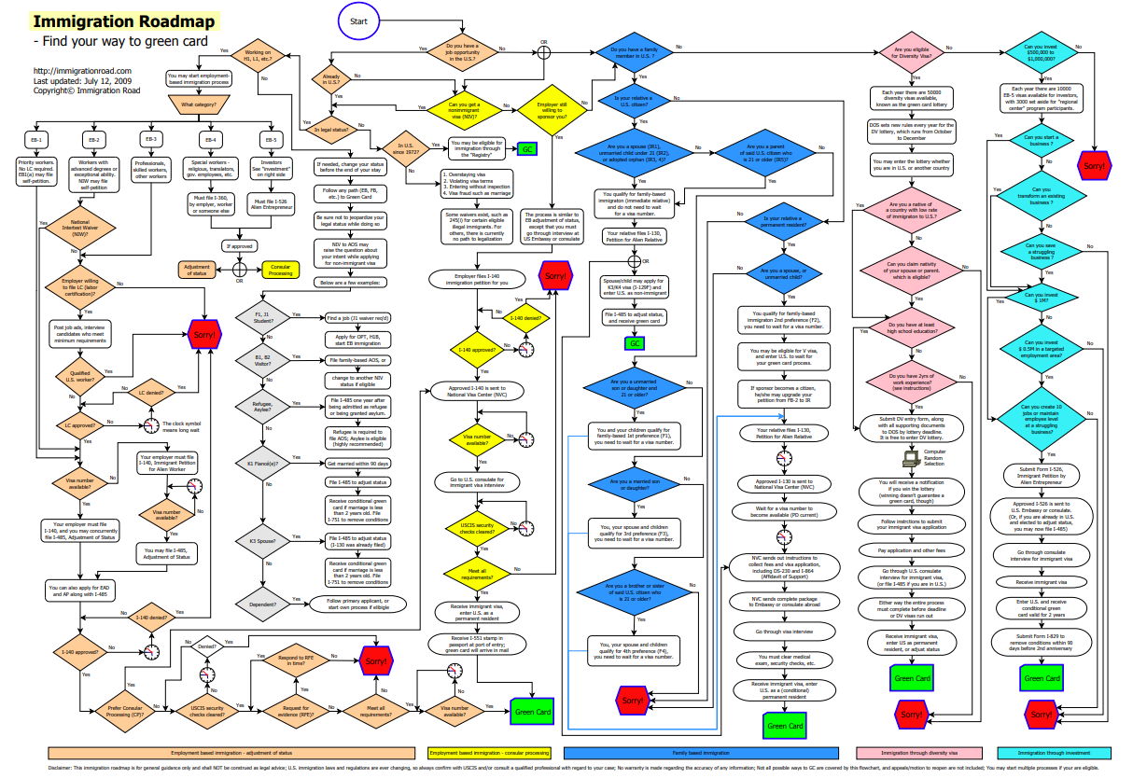

V. Resources

A. Erie-Related
Ghosheh, Baher. Can New Americans Reverse Erie’s Population Decline? Jefferson Educational Society. January 2022? 6 pages. Available free at: www.jeserie.org/uploads/Essays/Ghosheh%20-%20Reverse%20Population.pdf.
New American Economy. New Americans in Erie County PA: The Demographic and Economic Contributions of Immigrants in the County. June 2021. 8 pages. Available free at: https://research.newamericaneconomy.org/report/new-americans-in-erie-county/
Owens, Mark F. and James A. Kurre. The Role of Foreign-Born Residents in the Economy of Erie County PA. Erie PA: Economic Research Institute of Erie, September 2021. 64 pages. Available free at: https://eriedata.bd.psu.edu/.
They say: This study uses data from the Census Bureau’s American Community Survey (ACS) for the five-year period 2015-19. Based on a sample of approximately 5% of the population, the ACS provides estimates of the size and activities of the foreign-born and native-born in Erie and the nation. The first two parts of the report present data from that source, and the third part uses the data to answer some interesting questions.

B. Immigration-Related
Azoulay, Pierre, Benjamin Jones, J. Daniel Kim and Javier Miranda. Immigration and Entrepreneurship in the United States. National Bureau of Economic Research Working Paper 27778, September 2020. 39 pages. Available free at: https://www.nber.org/papers/w27778.
They say: Immigration can expand labor supply and create greater competition for native-born workers. But immigrants may also start new firms, expanding labor demand. This paper uses U.S. administrative data and other data resources to study the role of immigrants in entrepreneurship. We ask how often immigrants start companies, how many jobs these firms create, and how these firms compare with those founded by U.S.-born individuals. A simple model provides a measurement framework for addressing the dual roles of immigrants as founders and workers. The findings suggest that immigrants act more as "job creators" than "job takers" and that non-U.S. born founders play outsized roles in U.S. high-growth entrepreneurship.
Baugh, Carolyn. Our own Carolyn Baugh has published three novels based on her experience and scholarship. Shoreline, the second of her series about Egyptian-American detective Nora Khalil, is set in Erie.
-Baugh, Carolyn. The View from Garden City. New York: Forge Publishers, 2008.
-Baugh, Carolyn. Quicksand. New York: Forge Publishers, 2015.
-Baugh, Carolyn. Shoreline. New York: Forge Publishers, 2017.
Baxter, Andrew M. and Alex Nowrasteh. A Brief History of U.S. Immigration Policy from the Colonial Period to the Present Day. Cato Policy Analysis No. 919. August 3, 2021. 32 pages. Available for free download at: https://www.cato.org/sites/cato.org/files/2021-07/policy-analysis-919-revised.pdf
Brookings Institution, Immigration Facts Series: https://www.brookings.edu/series/immigration-facts-series/
They say: The Brookings Institution is a nonprofit public policy organization based in Washington, DC. Our mission is to conduct in-depth research that leads to new ideas for solving problems facing society at the local, national and global level. Brookings brings together more than 300 leading experts in government and academia from all over the world who provide the highest quality research, policy recommendations, and analysis on a full range of public policy issues.
Caplan, Bryan and Zach Weinersmith. Open Borders: The Science and Ethics of Immigration. New York: First Second Publishing, 2019. 256 pages.
A very readable introduction to key issues of immigration in a comic-book format, but with exhaustive research and citations to the academic literature and data.
Griswold, Daniel. The Benefits of Immigration: Addressing Key Myths. Mercatus Center (George Mason University) Policy Brief. May 2018. 6 pages. Available free at: https://www.mercatus.org/system/files/griswold_-_policy_brief_-_myths_of_immigration_-_v1.pdf
Hakakian, Roya. A Beginner’s Guide to America (for the Immigrant and the Curious.) New York: Alfred A. Knopf, 2019. 240 pages.
They say: Written as a "guide" for the newly arrived, and providing "practical information and advice," Roya Hakakian, an immigrant herself, reveals what those who settle here love about the country, what they miss about their homes, the cruelty of some Americans, and the unceasing generosity of others. She captures the texture of life in a new place in all its complexity, laying bare both its beauty and its darkness as she discusses race, sex, love, death, consumerism, and what it is like to be from a country that is in America's crosshairs.
Nowrasteh, Alex. The Most Common Arguments against Immigration and Why They're Wrong. Libertarianism.org Press. 2021. 40 pages. Available free at: https://www.immigrationresearch.org/system/files/The%20Most%20Common%20Arguments%20Against%20Immigration%20and%20Why%20Theyre%20Wrong.pdf
They say: Contains the 15 most common arguments against immigration, and Cato Institute scholar Alex Nowrasteh’s responses to them.
Nowrasteh, Alex and Benjamin Powell. Wretched Refuse? The Political Economy of Immigration and Institutions. Cambridge UK: Cambridge University Press, 2020.
U. S. Citizenship and Immigration Services. A Guide to Naturalization. (M-476). Available at: https://www.uscis.gov/citizenship/learn-about-citizenship/citizenship-and-naturalization/a-guide-to-naturalization

C. Useful Websites and Organizations
American Civil Liberties Union, Immigrants’ Rights: https://www.aclu.org/issues/immigrants-rights
They say: The fundamental constitutional protections of due process and equal protection embodied in our Constitution and Bill of Rights apply to every person, regardless of immigration status.
American Immigration Council: https://www.americanimmigrationcouncil.org/
They say: The American Immigration Council works to strengthen America by shaping how America thinks about and acts towards immigrants and immigration and by working toward a more fair and just immigration system that opens its doors to those in need of protection and unleashes the energy and skills that immigrants bring. We bring together problem solvers and employs four coordinated approaches to advance change—litigation, research, legislative and administrative advocacy, and communications.
Brookings Institution, Immigration: https://www.brookings.edu/topic/immigration/
They say: The Brookings Institution is a nonprofit public policy organization based in Washington, DC. Our mission is to conduct in-depth research that leads to new ideas for solving problems facing society at the local, national and global level. Brookings brings together more than 300 leading experts in government and academia from all over the world who provide the highest quality research, policy recommendations, and analysis on a full range of public policy issues.
Cato Institute, International Immigration: https://www.cato.org/immigration
They say: Most Americans are immigrants or descended from immigrants who sought opportunity and freedom on our shores. They and their children worked hard, assimilated, and added to our nation’s prosperity. Immigrants today continue to become Americans and, in the process, make the United States a wealthier, freer, and safer country. However, our current immigration system excludes most peaceful and healthy immigrants. Congress should look to America’s past for inspiration to expand and deregulate legal immigration.
About Cato: The vision of the Cato Institute is to create free, open, and civil societies founded on libertarian principles.
Georgetown Law Library, Immigration Organizations: https://guides.ll.georgetown.edu/c.php?g=273371&p=1824790
Their guide to websites of immigration law research and policy institutes, think tanks, and organizations.
Migration Policy Institute: https://www.migrationpolicy.org/
They say: The nonpartisan Migration Policy Institute seeks to improve immigration and integration policies through authoritative research and analysis, opportunities for learning and dialogue, and the development of new ideas to address complex policy questions. Founded in 2001, MPI is headquartered in Washington, DC. MPI provides analysis, development, and evaluation of migration and refugee policies at local, national, and international levels. It aims to meet the rising demand for pragmatic and thoughtful responses to the challenges and opportunities that large-scale migration, whether voluntary or forced, presents to communities and institutions in an increasingly integrated world.
New American Economy: https://www.newamericaneconomy.org/
They say: New American Economy is a bipartisan research and advocacy organization fighting for smart federal, state, and local immigration policies that help grow our economy and create jobs for all Americans.
NOTE: in 2022 New American Economy is merging with American Immigration Council, and will assume that name.
Pew Research Center, Immigration & Migration: https://www.pewresearch.org/topic/immigration-migration/
They say: Pew Research Center is a nonpartisan fact tank that informs the public about the issues, attitudes and trends shaping the world. We conduct public opinion polling, demographic research, content analysis and other data-driven social science research. We do not take policy positions. We generate a foundation of facts that enriches the public dialogue and supports sound decision-making. We are nonprofit, nonpartisan and nonadvocacy. We value independence, objectivity, accuracy, rigor, humility, transparency and innovation.
U. S. Citizenship and Immigration Services: https://www.uscis.gov/
They say: U.S. Citizenship and Immigration Services administers the nation’s lawful immigration system, safeguarding its integrity and promise by efficiently and fairly adjudicating requests for immigration benefits while protecting Americans, securing the homeland, and honoring our values.
U.S. Committee for Refugees and Immigrants: https://refugees.org/
They say: We believe that our American character is based on fundamental values that embrace the newcomer with equal rights and equal opportunity. In return, America prospers—built by those who have placed their bets on the idea of America, e pluribus unum ("from many, one"). Our mission: To protect the rights and address the needs of persons in forced or voluntary migration worldwide and support their transition to a dignified life.
U.S. Department of Homeland Security, Immigration Data and Statistics: https://www.dhs.gov/immigration-statistics
They say: Since the passage of the Homeland Security Act of 2002, the Office of Immigration Statistics has responsibility to carry out two statutory requirements: 1) to collect and disseminate to Congress and the public data and information useful in evaluating the social, economic, environmental, and demographic impact of immigration laws; and 2) to establish standards of reliability and validity for immigration statistics collected by the Department’s operational Components.

APPENDIX 1: Bylaws of MCRC

BYLAWS
OF
Multicultural Community Resource Center
Amended and restated as of
December 18, 2019

ARTICLE I – OFFICES 1
ARTICLE II – PURPOSE 1
ARTICLE III - MEMBERS 1
ARTICLE IV – DIRECTORS 2
ARTICLE V – PERSONAL LIABILITY OF DIRECTORS 2
ARTICLE VI – OFFICERS OF THE MCRC 6
ARTICLE VII – VACANCIES 8
ARTICLE VIII – BOOKS AND RECORDS 11
ARTICLE IX – TRANSACTION OF BUSINESS 12
ARTICLE X – NOTICES 12
ARTICLE XI – MISCELLANEOUS PROVISIONS 13
ARTICLE XII – INDEMNIFICATION OF DIRECTORS, OFFICERS, EMPLOYEES AND AGENTS; DISSOLUTION 18

Appendix A - Timeline i
Appendix B – MCRC Non-Profit Board Member Expectations ii
Appendix C - Conflict of Interest Policy………………………………………………….v

BYLAWS OF
Multicultural Community Resource Center

– OFFICES

Name of the Agency.
The name of the Agency shall be: The Multicultural Community Resource Center (MCRC). P.K.A. The Hispanic American Council.

Initial Office.
The registered office of MCRC shall be at 554 East 10th Street, Erie, Pennsylvania, but at any point the location can change to anywhere the Executive Board deems fit.

Other Offices.
MCRC may also have offices at such other places as the Board of Directors may from time to time appoint or the activities of the Council may require.

MCRC Annex – 538 East 10th Street, Erie, PA.

MOSAICO – 554 East 10th Street, Erie, PA.

ARTICLE II- PURPOSE

General.
The purpose of MCRC is stated in its mission statement, which is incorporated herein by reference. It is the duty of the Executive Director and each member of the Board of Directors of MCRC to become familiar with such purpose.

Non-Discrimination.
The MCRC endorses a nondiscriminatory policy as to its operations such that the MCRC shall operate without regard to race, ethnicity, religion, national origin, disability, gender or sexual orientation.

I – MEMBERS

Members.
As provided in ARTICLE VI of the Articles of Incorporation, MCRC shall have no members, as such. Accordingly, any provision of law requiring notice to, the presence of, or the vote, consent, or other action by members of a nonprofit corporation shall be satisfied by notice to, the presence of, or the vote, consent, or other action by the Board of Directors.

ARTICLE IV – DIRECTORS

Number and Qualification.
The business and affairs of MCRC shall be managed by its Board of Directors, which shall be between nine (9) and fifteen (15) in number. The directors shall be natural persons who are at least 20 years of age and need not be residents of the Commonwealth of Pennsylvania. Succession on the Board of Directors shall be governed by this ARTICLE and by ARTICLE VI, Section 2 of these Bylaws. A former employee of MCRC can only be permitted to serve on the Board of Directors if, and only if, the Board of Directors deems his/her previous performance as an employee, satisfactory.

Term and Election.

A Board Term Limit Cycle is defined as three (3) board terms and one (1) year off. A board term shall be for a period of three (3) years. A director must be reinstated for each term and take one (1) year off from the board after three (3) terms. After taking one (1) year off and the board member is reinstated, this will restart the term limit cycle. If a board member resigns during a term, it will count as one (1) full term for the purposes of calculating the Board Term Limit Cycle.

The individual terms of every director elected shall begin on the date of acceptance by the Board of Directors as a Board Member. Board Members shall have up to thirty (30) days prior to the expiration of the term to notify in writing to the Executive Board the desire to continue as a board member. Reinstatement will be subject to the approval by the Board of Directors at the next available meeting. Failure to do so will result in the automatic expiration of the term.

The Board of Directors shall elect directors to fill the terms expiring on December 31 of the year (refer to Appendix A for schedule). Each term shall be filled by a nominee elected by a majority vote of the directors present at the annual meeting.

Vacancies on the Board of Directors due to death, resignation, or removal, shall be filled in accordance with ARTICLE VII of these Bylaws.

All newly elected Board members are required to sign a conflict of interest statement before their term is scheduled to begin, and annually thereafter. A copy of the conflict of interest statement can be found in Appendix B.

Powers.

General. In addition to the powers and authorities expressly conferred upon the Board of Directors by statute, by the Articles of Incorporation, and by these Bylaws, the Board of Directors may exercise all such power of MCRC and do all such lawful acts and things as are by statute directed or required to be exercised or done by members.

Action by Resolution. Actions of the Board of Directors may only be taken by resolution adopted by such number of directors as is specified in these Bylaws at a regular, special, or annual meeting of the Board of Directors which has been convened in accordance with the requirements of these Bylaws. Unless specifically authorized by these Bylaws or by a duly adopted resolution of the Board of Directors, no individual director, officer, or committee of MCRC, or the Board of Directors, shall have the authority to bind MCRC, or to direct the conduct of any of the affairs of MCRC.

Notation of Dissent. A director who is present at a meeting of the Board of Directors, or of a committee of the board, at which action on any corporate matter is taken shall be presumed to have assented to the action taken unless his or her dissent is entered in the minutes of the meeting or unless the director files a written dissent to the action with the secretary of the meeting before the adjournment thereof or transmits the dissent in writing to the secretary of the MCRC immediately after the adjournment of the meeting. The right to dissent shall not apply to a director who voted in favor of the action. Nothing in this section shall bar a director from asserting that minutes of the meeting incorrectly omitted his or her dissent if, promptly upon receipt of a copy of such minutes, the director notifies the secretary, in writing, of the asserted omission or inaccuracy.

Special Meetings.
Other meetings of the Board of Directors may be held at such times and at such places within the Commonwealth of Pennsylvania, or elsewhere, as a majority of the directors or the President may from time to time designate. The Secretary shall give notice (written or otherwise) of every special meeting to each director at least five (5) days prior to the day named for the meeting.
The President may submit resolutions for Board consideration via email solicitation when necessary for the efficient operation of the organization. An affirmative vote of the prevailing quorum number is required for passage and, upon passage, such resolutions shall have the same force as if adopted at a regular meeting of the Board.

Regular Meetings.
Regular meetings of the Board of Directors shall take place bi-monthly. In the event that there is not sufficient MCRC business to warrant a meeting, the Board President after consultation with the Executive Director, will notify in writing each member of the Board of Directors. This decision should be made at least five (5) days preceding the regularly scheduled meeting.

Conduct of Meetings.

Quorum. A majority of the members of the Board of Directors then in office shall constitute a quorum for the transaction of business: Provided, however, that if a quorum is not achieved for two consecutive regular meetings, (proper notice of a re-scheduled annual meeting having been given to all members of the Board of Directors), then the directors present at the second regular meeting, or the rescheduled annual meeting, shall be deemed to constitute a quorum for the purpose of adopting resolutions of Board of Directors.

Voting. Voting shall be by voice vote: Provided, however, that upon the request of any member of the Board of Directors, the election of members and officers of the Board of Directors shall be by secret ballot.

Procedure. The President or any officer acting in the place of the President shall chair meetings of the Board of Directors. Unless otherwise specifically provided in these Bylaws, the procedures followed at any meeting shall be in accordance with the rulings of the chair. If any member of the Board of Directors objects to a ruling of the chair, such member may make a point of procedure and move that the Board of Directors overrule the ruling of the chair. If such motion receives a second, the motion shall be voted upon immediately and without debate by the Board of Directors. If the motion is defeated, the ruling of the chair shall stand. If the motion is adopted, the procedure followed shall be in accordance with the motion.

Committees.
The Board of Directors may, by resolution, establish one or more committees. Appointments to committees shall be made by the President taking into account, insofar as is reasonably possible, the particular talents and interests of each appointee. Appointees may, but need not be, members of the Board of Directors. Any such committee shall be advisory in nature and shall not itself have the power to exercise any of the powers or authority of the Board of Directors itself, unless specifically authorized to do so by resolution of the Board of Directors.

Salaries.
The Board of Directors shall not be entitled to receive any compensation for their services as such. However, a director may serve MCRC in any other capacity, and receive compensation for those services, subject, however, to the provisions of these Bylaws dealing with the disallowable compensation.

Removal.

Any director may be removed from office, with or without a showing of cause, upon the affirmative vote of the majority of the directors in office at a meeting of the Board. The Board of Directors may also declare vacant the office of a director if he is declared of unsound mind by an order of court or is convicted of a felony, or if within sixty (60) days after notice of his election, he does not accept such office either in writing or by attending a meeting of the Board of Directors, and fulfill such other requirements or qualifications as the Bylaws may specify.

Members are permitted two (2) absences in a one (1) year period. Upon a fourth absence, the board may exercise the right to remove the member. The member may present an excuse for the board’s consideration. A majority vote will determine whether to remove the member or accept the excuse.

ARTICLE V – PERSONAL LIABILITY OF DIRECTORS

Personal Liability of Directors.
No director of MCRC shall be personally liable for monetary damages as such, for any action taken, or his failure to take any action, unless:

Such director has breached or failed to perform the duties of his office under ARTICLE IV of these Bylaws or under this ARTICLE V, Section 2, below, and;

The breach or failure to perform constitutes self-dealing, willful misconduct or recklessness; but provided, however, that the provisions of this section shall not apply to:

The responsibility of a director pursuant to any criminal statute; or

The liability of a director for the payment of taxes pursuant to local, state, or federal law.

Directors’ Standard of Care and Justifiable Reliance.

The Subsequent provisions of this ARTICLE V are adapted from and conform to certain provisions of the Directors’ Liability Act of Pennsylvania, as now contained in 42 Pennsylvania Consolidated Statutes, Section 8363. If such statutory provisions are amended, then this ARTICLE V shall be deemed amended accordingly.

A director of MCRC shall stand in a fiduciary relation to MCRC and shall perform duties as a director, including duties as a member of any committee of the Board upon which he/she may serve, in good faith, in a manner he reasonably believes to be in the interests of MCRC, and with such care, including reasonable inquiry, skill and diligence, as a person of ordinary prudence would use under similar circumstances. In performing his/her duties, a director shall be entitled to rely in good faith on information, opinions, reports or statements, including financial statements and other financial data, in each case prepared or presented by any of the following:

One or more officers or employees of MCRC whom the director reasonably believes to be reliable and competent in the matters presented;

Counsel, public accountants or other persons as to matters which the director reasonably believes to be within the professional or expert competence of such person.

A committee of the Board upon which committee he/she does not serve, duly designated in accordance with the law or these Bylaws as to matters within its designated authority, which committee the director reasonably believes to merit confidence. A director shall not be considered to be acting in good faith if he/she has knowledge concerning the matter in question that would cause his/her reliance to be unwarranted.

In discharging the duties of their respective positions, the Board of Directors, committees of the Board, and individual directors may, in considering the best interests of MCRC, consider the effect of any action upon employees, upon suppliers and customers of MCRC and upon communities in which officer or other establishments of MCRC are located, and all other pertinent factors. The consideration of those factors shall not constitute a violation of subsection (b).

Absent breach of fiduciary duty, lack of good faith or self-dealing, actions taken as a director or any failure to take any action shall be presumed to be in the best interest of MCRC.

ARTICLE VI – OFFICERS OF THE MCRC

Officers.
Executive officers of MCRC shall be a President, Vice President, and Secretary. The executive officers shall be elected annually at the annual meetings (see Appendix A for schedule) by the Board of Directors and shall have such authority and shall perform such duties as are provided by the Bylaws and as shall from time to time be prescribed by the Board. The Board of Directors may secure the fidelity of any or all such officers by bond or otherwise.

Removal.
Any officer or agent of MCRC may be removed by the Board of Directors whenever in its judgment the best interests of MCRC will be served thereby, but such removal shall be without prejudice to the contract rights of any person so removed.

Resignations.
Any officer may resign at any time upon written notice to the MCRC. The resignation shall be effective upon receipt thereof by the MCRC or at such subsequent time as may be specified in the notice of resignation.

Standard of Care.
Except as otherwise provided in the Articles, an officer shall perform his/her duties as an officer in good faith, in a manner he/she reasonably believes to be in the best interests of the MCRC and with such care, including reasonable inquiry, skill and diligence, as a person of ordinary prudence would use under similar circumstances. A person who so performs his/her duties shall not be liable by reason of having been an officer of the MCRC.

President.
The President shall preside at all meetings of the Board. The President shall see that all orders and resolutions of the Board are carried into effect, subject, however, to the right of the director to delegate any specific powers, except such as may be by statute exclusively conferred on by the President or to any other officer or officers of MCRC.

Vice President.
The Vice President shall act in all cases for and, as the President in the latter’s absence or incapacity, and shall perform such other duties as he/she may be required to do from time to time.

Secretary.
The Secretary shall attend all sessions of the Board and act as clerk thereof, and record all the votes of the Board and the minutes of all its transactions and email minutes to all Directors prior to the next meeting; and shall perform like duties for all committees of the Board of Directors when required. He/she shall give, or cause to be given, notice of all meetings of the Board of Directors, and shall perform such other duties as may be prescribed by the Board of Directors or the President, under whose supervision he/she shall carry out his/her duties.

Executive Director.
The Executive Director shall be the Chief Operating Officer of MCRC, and shall have general and active management of the day to day affairs of MCRC. The Executive is neither a member of the Board of Directors nor the Executive Committee. The Executive Director shall also have such other responsibilities as may from time to time be delegated to him/her by the President and such authority as may from time to time be conferred upon him/her by the Board of Directors. In carrying out his/her duties and responsibilities, the Executive Director shall at all times act in conformity with such policies and decisions as have been adopted by the Board of Directors. The Board, through the Personnel Committee, shall conduct an annual review of the Executive Director.

Disallowed Compensation.
Any payments made to an officer, director, or employee of the MCRC such as a salary, commission, bonus, interest, rent, travel or entertainment expense (hereinafter, the "compensation") as a deductible expense by the Internal Revenue Service, shall be reimbursed by such officer or employee to the MCRC to the full extent of such disallowance. It shall be the duty of the Board of Directors to enforce payment of each such amount disallowed. In lieu of payment by the officer or employee, subject to the determination of the directors, proportionate amounts may be withheld from future compensation payments until the amount owed to the MCRC has been recovered. Furthermore, any compensation payable to an officer or employee of the MCRC shall be reasonable in relation to the services performed by such an officer or an employee and shall be subject to the "excess benefit" rule, the "private inurement" rule, or any other restrictions imposed by the Code and applicable case law on Section 501(c)(3) public charitable organizations.

ARTICLE VII – VACANCIES

Offices.
If the office of any officer or agent becomes vacant for any reason, the Board of Directors shall appoint a successor or successors, who shall hold office for the unexpired term of that office.

Directors.
Vacancies in the Board of Directors resulting from the death, resignation, or removal of a director, shall be filled by a two-thirds (2/3) majority vote of the remaining members present at a special, regular, or annual meeting. Each person selected shall be a director until expiration of the term of that director being replaced.

ARTICLE VIII – BOOKS AND RECORDS

Place.
MCRC shall keep an original or duplicate record of the proceedings of the Board, and the original or a copy of its Bylaws, including all amendments thereto date, certified by the Secretary of MCRC. MCRC shall also keep appropriate, complete and accurate books or records of account. The records provided for herein shall be kept at either the registered office of MCRC in this Commonwealth, or at its principal place of business, wherever situated.

Right to Examine.
Every director shall, upon written demand under oath stating the purpose thereof, have a right to examine for any proper purpose, in person or by agent or attorney, during the usual hours for business, the books and records of account, and records of the proceedings of the Board, and to make copies of extracts therefrom. A proper purpose shall mean a purpose reasonably related to the interest of such person as a director. In every instance where an attorney or other agent shall be the person who seeks the right to inspection, the demand under oath shall be accompanied by a power of attorney or such other writing which authorizes the attorney or other agent to do such act on behalf of the director. The demand under oath shall be directed to MCRC at its registered office in the Commonwealth of Pennsylvania or at its principal place of business, wherever situated.

ARTICLE IX – TRANSACTION OF BUSINESS

Purchase and Sales.
MCRC shall make no purchase of property nor sell, mortgage, lease away or otherwise dispose of any property for an amount greater than $10,000.00, unless authorized by a vote of more than two-thirds (2/3) of the Board of Directors present at a meeting of the Board of Directors. Property that is purchased as a unit can be broken into smaller units but would still require board approval.

Incidental Profits.
Whenever the lawful activities of MCRC involve, among other things, the charging of fees or prices for its services or products, it shall have the right to receive such income, and in so doing, may make an incidental profit. All such incidental profits shall be applied to the maintenance and operation of the lawful activities of MCRC, and in no case shall be divided or distributed in any manner whatsoever among the directors or officers of MCRC.

Checks, etc.
All checks or demands for money and notes of MCRC shall be signed by such officer, or officers, as the Board of Directors may from time to time designate.

Fiscal Year.
The fiscal year of MCRC shall begin July 1 of each year (refer to Appendix A).

Personal Benefit Prohibited.
No director, officer, employee, or other person may utilize the resources or personnel of MCRC except for the conduct of the business of MCRC or as may otherwise be authorized by resolution of the Board of Directors.

ARTICLE X – NOTICES

Written Notice.
Whenever written notice is required to be given to any person, it may be given to such person, either personally or by sending a copy thereof by first class mail, postage prepaid, to his/her address appearing on the books of the MCRC, or to such e-mail address as was supplied by him/her to MCRC for the purpose of notice. When the notice is sent by mail, it shall be deemed to have been given to the person entitled thereto when deposited in the United States mail for transmission to such person. Such notice shall specify the place, day and hour of the meeting and any other information required by statute or these Bylaws.

Waiver of Notice.
Whenever any written notice is required to be given under law, the Articles of Incorporation or the Bylaws of MCRC, a waiver thereof in writing, signed by the person or persons entitled to such notice, whether before or after the time stated therein, shall be deemed equivalent to the giving of such notice. Except as otherwise required by statute, neither the business to be transacted nor the purpose of a meeting need to be specified in the waiver of notice of such meeting. Attendance of a person at any meeting shall constitute a waiver of notice of such meeting, except where a person attends a meeting for the express purpose of objecting, at the beginning of the meeting, to the transaction of any business because the meeting was not lawfully called or convened.

ARTICLE XI – MISCELLANEOUS PROVISIONS

Conference Telephone.
Upon 24 hours’ notice, one or more directors may participate in a meeting of the Board, or a committee of the Board, by means of conference telephone or similar communications equipment through which all persons participating in the meeting can hear each other. Participation in a meeting pursuant to this section constitutes presence in person at such meeting. In the case of confidential discussion in Executive Session, at the discretion of the presiding officer, the telephone connection may be suspended until the confidential discussion has ended.

Annual Report.
Within sixty days after receipt of the annual audit, the Board of Directors shall be presented with an annual report. Such report shall be verified by the President or the Treasurer and shall show in appropriate detail the following information:

The assets and liabilities of MCRC as of the end of such fiscal year,

The principal changes in the assets and liabilities occurring during such year,

The revenue, receipts and sources of income, both restricted and unrestricted, for such year,

The expenses or disbursements of MCRC, for both restricted and unrestricted purposes, for such year, and

A statement of the names of the directors of MCRC as of the end of such year.

Number and Gender.
Any words or terms used here in the singular shall be read as if written in the plural, or vice versa, when appropriate. Words of masculine, feminine or neuter import shall be read as if written in the neuter or masculine or feminine when appropriate.

ARTICLE XII
INDEMNIFICATION OF DIRECTORS, OFFICERS, EMPLOYEES AND AGENTS; DISSOLUTION

Actions Involving Directors, Officers or Employees.
MCRC may indemnify any person who was or is a party (other than a party plaintiff suing on his/her own behalf or in the right of MCRC), or who is threatened to be made such a party, to any threatened, pending or completed action, suit or proceeding, whether civil, criminal, administrative or investigative (including, but not limited to, an action by or in the right of MCRC) by reason of the fact that he/she is or was a director, officer or employee of MCRC, or is or was serving at the request of MCRC as a director, officer or employee of another MCRC, partnership, joint venture, trust or other enterprise, against expenses (including attorneys’ fees), judgments, fines and amounts paid in settlement actually and reasonably incurred by him/her in connection with such action, suit or proceeding; provided, that no person shall be indemnified:

except to the extent that aggregate of losses to be indemnified under the provisions of this Article exceeds the amount of such losses for which the director, officers’ liability insurance policy maintained by MCRC;

in respect to remuneration paid to such person if it shall be finally adjudged that such remuneration was in violation of law;

on account of such person’s conduct which is finally adjudged to have been knowingly fraudulent, deliberately dishonest or constituted willful misconduct or recklessness, and

if it shall be finally adjudged that such indemnification is not lawful.

Actions Involving Agents.
MCRC may indemnify any person who was or is a party (other than a party plaintiff suing on his/her own behalf or in the right of MCRC), or who is threatened to be made such a party, to any threatened, pending or completed action, suit or proceeding, whether civil, criminal, administrative or investigative (including, but not limited to, an action by or in the right of MCRC) by reason of the fact that he/she is an agent of MCRC, or is or was serving at the request of MCRC as an agent of another corporation, partnership, joint venture, trust or other enterprise, against expenses (including attorneys’ fees), judgments, fines and amounts paid in settlement actually and reasonably incurred by him/her in connection with such action, suit or proceeding, all to the full extent permitted by law.

Determination of Right to the Indemnification in Certain Instances.

Any indemnification under Section 1 of this Article (unless ordered by a court) shall be made by MCRC unless a determination is reasonably and promptly made that indemnification of the director, officer or employee is not proper in the circumstances because he/she has not satisfied the conditions set forth in such Section 1. Such determination shall be made (1) by the Board by a majority vote of a quorum consisting of directors who were not parties to such action, suit or proceeding, or (2) if such a quorum is not obtainable, or, even if obtainable, a quorum of disinterested directors so directs, by independent legal counsel in a written opinion.

Any indemnification under Section 2 of this Article (unless ordered by a court) shall be made by MCRC only as authorized in the specific case upon a determination that indemnification of the agent is proper in the circumstances because he/she has met the applicable standard of conduct set forth in such Section 2. Such determination shall be made:

by the Board by a majority vote of a quorum consisting of directors who were not parties to such action, suit or proceeding; or

if such quorum is not obtainable, or even if obtainable, a quorum of disinterested directors so directs, by independent legal counsel in a written opinion.

Advance Payment of Expenses.
Expenses incurred by defending a civil or criminal action, suit or proceeding may be paid by MCRC in advance of the final disposition of such action, suit or proceeding upon receipt of an undertaking by or on behalf of the director, officer, employee or agent to repay such amount if it shall ultimately be determined that he/she is not entitled to be indemnified by MCRC as authorized in this Article.

Successful Defense.
Notwithstanding, any other provisions of this Article, to the extent that a director, officer, employee or agent of MCRC has been successful on the merits or otherwise (including the dismissal of an action without prejudice or the settlement of an action without admission of liability) in defense of any action, suit or proceeding referred to in Sections 1 or 2 of this Article, or in defense of any claim, issue or matter therein, he/she shall be indemnified against expenses (including attorneys’ fees) actually and reasonably incurred by him/her in connection therewith.

Not Exclusive Right.
The indemnification provided by this Article shall not be deemed exclusive of any other rights to which those seeking indemnification may be entitled under any statute, bylaw, agreement, vote of disinterested directors or otherwise, both as to action in an official capacity and as to action in another capacity while holding such office. Without limiting the generality of the foregoing, in the event of conflict between the provisions of this Article and the provisions of any written agreement between MCRC on the one hand, and any director, officer, employee or agent of MCRC, of the other providing for indemnification, the terms of such written agreement shall prevail. Any indemnification, whether required under bylaw or permitted by statute or otherwise, shall continue as to a person who has ceased to be a director, officer or employee and shall inure to the benefit of the heirs, executors and administrators of such person.

Insurance.
The Board shall have the power to cause MCRC to purchase and maintain, on behalf of any person who is or was a director, officer, employee or agent of MCRC, or is or was serving at the request of the Council as a director, officer, employee or agent of another corporation, partnership, joint venture, trust or other enterprise against any liability asserted against him/her and incurred by in any such capacity, arising out of his/her status as such, whether or not MCRC would have the power to indemnify him/her against such liability under the provision of this Article.

Section 501(c)(3) Status.
Notwithstanding any provision of this Article to the contrary, if any action or activity listed in this Article violates statutory and/or judicial prohibitions imposed upon Section 501(c)(3) public charities, such actions or activities shall be null and void ab initio.

Dissolution.
Upon the dissolution of MCRC, the Board of Directors shall, after paying or making provision for the payment of all the liabilities of MCRC, dispose of all the assets of MCRC exclusively for the purposes of MCRC in such manner, or to such organization or organizations organized and operated exclusively for charitable, educational, religious, or scientific purposes as shall at the time qualify as an exempt organization or organizations under Section 501C(3) of the Internal Revenue Code of 1986 (or corresponding provision of any future United States Internal Revenue Law), as amended, as the Board of Directors shall determine. Any such assets not so disposed of shall be disposed of by the Court of Common Pleas of the county in which the principal office of the MCRC is then located, exclusively for such purposes as said court shall determine, which are organized and operated exclusively for such purposes.

ARTICLE XIII – AMENDMENT
These Bylaws may be adopted, amended or repealed by the vote of at least two-thirds (2/3) of the directors in office at any (annual, regular, and/or special) two consecutive meetings of the Board. Such meetings shall be separated by a period of time, which shall be no less than seven (7) days in duration.

Bylaws Appendix A – Timeline

January | Start term of Board of Directors
July | Fiscal Year begins
July - September | Annual Audit
September – October | Annual Audit Report Meeting
October – November | Nominations
November – December | Annual Meeting / Elections
December 31st | Terms Expire for given expiration

Bylaws Appendix B

MCRC Non-profit Board Member Expectations
I understand that as a member of the Board of Directors of the Multicultural Community Resource Center (MCRC), I have a legal and moral responsibility to ensure that MCRC does the best work possible in pursuit of its goals. I believe in the purpose and the mission of MCRC, and I will act responsibly and prudently as its steward.
As part of my responsibilities as a board member:
- I will interpret MCRC's work and values to the community, represent MCRC, and act as spokesperson.
- I will attend at least 66% of board meetings, committee meetings, and special events.
- I will make a yearly personal financial contribution at a level that is meaningful to me.
- I will actively participate in all assigned fundraising activities.
- I will understand and agree to MCRC’s Board of Directors Conflict of Interest Statement and it is my responsibility to update MCRC when there are changes in my contact information, before the next board meeting.
- I will stay informed about what's going on at MCRC, and I will ask questions and request information as needed to do so. I will participate in and take responsibility for making decisions on issues, policies and other board matters.
- I will work in good faith with staff and other board members as partners towards achievement of our goals.
- I understand that any personal activity, whether illegal or immoral, may have a bad reflection on MCRC.
- If I don't fulfill these commitments to MCRC, I will expect the board president to call me and discuss my responsibilities with me.
- In turn, the MCRC will be responsible to me in several ways:
- I will be sent, without request, bimonthly financial reports and an update of organizational activities that allow me to meet the "prudent person" section of the law, no later than the Monday prior to each Board meeting.
- Opportunities will be offered to me to discuss with the executive director and the board president the organization's programs, goals, activities, and status; additionally, I can request such opportunities.
- MCRC will help me perform my duties by keeping me informed about issues in the industry and field in which we are working, and by offering me opportunities for professional development as a board member.
- Board members and staff will respond in a straightforward fashion to questions I have that I feel are necessary to carry out my fiscal, legal and moral responsibilities to this organization. Board members and staff will work in good faith with me towards achievement of our goals.
- If MCRC does not fulfill its commitments to me, I can call on the Board President and Executive Director to discuss these responsibilities.

Date: ______________________ | _____________________________________
 | ______________________, Director

(SEAL) |  |  | THE COMPANY:
ATTEST: |  |  | MULTICULTURAL COMMUNITY RESOURCE CENTER
By: | _________________________ |  | By:
 | _______________Secretary |  |  | _____________________ President

Bylaws Appendix C

Multicultural Community Resource Center

Conflict of Interest POLICY

This conflict of interest policy is designed to help directors, officers and employees of MCRC identify situations that present potential conflicts of interest and to provide MCRC with a procedure which, if observed, will allow a transaction to be treated as valid and binding even though a director, officer or employee has or may have a conflict of interest with respect to the transaction.
- Conflict of Interest Defined. For purposes of this policy, the following circumstances shall be deemed to create Conflicts of Interest:
- Outside Interests.
- A Contract or Transaction between MCRC and a Responsible Person or Family Member.
- A Contract or Transaction between MCRC and an entity in which a Responsible Person or Family Member has a Material Financial Interest or of which such person is a director, officer, agent, partner, associate, trustee, personal representative, receiver, guardian, custodian, conservator or other legal representative.
- Outside Activities.
- A Responsible Person competing with MCRC in the rendering of services or in any other Contract or Transaction with a third party.
- A Responsible Person’s having a Material Financial Interest in, or serving as a director, officer, employee, agent, partner, associate, trustee, personal representative, receiver, guardian, custodian, conservator or other legal representative of, or consultant to, an entity or individual that competes with MCRC in the provision of services or in any other Contract or Transaction with a third party.
- Gifts, Gratuities and Entertainment. A Responsible Person accepting gifts, entertainment or other favors from any individual or entity that:
- Does or is seeking to do business with, or is a competitor of MCRC; or
- Has received, is receiving, or is seeking to receive a loan or grant, or to secure other financial commitments from MCRC;
- Is a charitable organization operating in the Commonwealth of Pennsylvania;
- Under circumstances where it might be inferred that such action was intended to influence or possibly would influence the Responsible Person in the performance of his/her duties. This does not preclude the acceptance of items of nominal or insignificant value or entertainment of nominal or insignificant value which are not related to any particular transaction or activity of MCRC.
- Definitions.
- A “Conflict of Interest" is any circumstance described in Part 1 of this Policy.
- A "Responsible Person" is any person serving as an officer, employee or member of the Board of Directors of MCRC.
- A "Family Member" is a spouse, domestic partner, parent, child or spouse of a child, brother, sister, or spouse of a brother or sister, of a Responsible Person.
- A "Material Financial Interest" in an entity is a financial interest of any kind, which, in view of all the circumstances, is substantial enough that it would, or reasonably could, affect a Responsible Person’s or Family Member’s judgment with respect to transactions to which the entity is a party. This includes all forms of compensation.
- A "Contract or Transaction" is any agreement or relationship involving the sale or purchase of goods, services, or rights of any kind, the providing or receipt of a loan or grant, the establishment of any other type of pecuniary relationship, or review of a charitable organization by MCRC. The making of a gift to MCRC is not a Contract or Transaction.
- Procedures.
- Prior to board or committee action on a Contract or Transaction involving a Conflict of Interest, a director or committee member having a Conflict of Interest and who is in attendance at the meeting shall disclose all facts material to the Conflict of Interest. Such disclosure shall be reflected in the minutes of the meeting.
- A director or committee member who plans not to attend a meeting at which he/she has reason to believe that the board or committee will act on a matter in which the person has a Conflict of Interest shall disclose to the chair of the meeting all facts material to the Conflict of Interest. The chair shall report the disclosure at the meeting and the disclosure shall be reflected in the minutes of the meeting.
- A person who has a Conflict of Interest shall not participate in or be permitted to hear the boards or committee’s discussion of the matter except to disclose material facts and to respond to questions. Such person shall not attempt to exert his/her personal influence with respect to the matter, either at or outside the meeting.
- A person who has a Conflict of Interest with respect to a Contract or Transaction that will be voted on at a meeting shall not be counted in determining the presence of a quorum for purposes of the vote. The person having a conflict of interest may not vote on the Contract or Transaction and shall not be present in the meeting room when the vote is taken, unless the vote is by secret ballot. Such person’s ineligibility to vote shall be reflected in the minutes of the meeting. For purposes of this paragraph, a member of the Board of Directors of MCRC has a Conflict of Interest when he/she stands for election as an officer or for re-election as a member of the Board of Directors.
- Responsible Persons who are not members of the Board of Directors of MCRC, or who have a Conflict of Interest with respect to a Contract or Transaction that is not the subject of Board or committee action, shall disclose to the Chair or the Chair’s designee any Conflict of Interest that such Responsible Person has with respect to a Contract or Transaction. Such disclosure shall be made as soon as the Conflict of Interest is known to the Responsible Person. The Responsible Person shall refrain from any action that may affect MCRC’s participation in such Contract or Transaction. In the event it is not entirely clear that a Conflict of Interest exists, the individual with the potential conflict shall disclose the circumstances to the Chair or the Chair’s designee, who shall determine whether there exists a Conflict of Interest that is subject to this policy.
- Confidentiality.
Each Responsible Person shall exercise care not to disclose confidential information acquired in connection with such status or information the disclosure of which might be adverse to the interests of MCRC. Furthermore, a Responsible Person shall not disclose or use information relating to the business of MCRC for the personal profit or advantage of the Responsible Person or a Family Member.
- Review of policy.
- Each new Responsible Person shall be required to review a copy of this policy and to acknowledge in writing that he/she has done so.
- Each Responsible Person shall annually complete a disclosure form identifying any relationships, positions or circumstances in which the Responsible Person is involved that he/she believes could contribute to a Conflict of Interest arising. Such relationships, positions or circumstances might include service as a director of or consultant to a nonprofit organization, or ownership of a business that might provide goods or services to MCRC. Any such information regarding business interests of a Responsible Person or a Family Member shall be treated as confidential and shall generally be made available only to the Chair, the Executive Director, and any committee appointed to address Conflicts of Interest, except to the extent additional disclosure is necessary in connection with the implementation of this Policy.
- This policy shall be reviewed annually by each member of the Board of Directors. Any changes to the policy shall be communicated immediately to all Responsible Persons.

_______________________________________________

MULTICULTURAL COMMUNITY RESOURCE CENTER
Conflict of Interest Information Form
Please describe below any relationships, positions, or circumstances in which you are involved that you believe could contribute to a Conflict of Interest as defined in the MCRC's Policy on Conflicts of Interest.

Name: ______________________________________
Date: _______________________________________

Appendix 2: Executive Director Position Description

Multicultural Community Resources Center
Position Description
Job Title: Executive Director
Department: Administration
Reports To: Board of Directors
FLSA Status: Exempt
Approved By: Board of Directors
Approved Date: 9/1/2013

Summary Serves as the agency chief administrative officer. Responsible for all areas of agency operations including: Programs and services offerings, personnel management, budget, contract compliance, public relations, fund development, etc. Functions as day-to-day program manager responsible for overseeing the business operations of MCRC. Directly supervises Associate Directors. Operates at the administrative level, providing effective leadership in planning, organizing, implementing, and directing all agency operations. Assures highest quality standards are upheld in all phases of program operations. Reports directly to the Board of Directors.

Essential Duties and Responsibilities include the following. Other duties may be assigned by the board or required as indicated by the daily needs of the organization.

Financial Management
- Approves the budget; manages the budget, including signing all contracts; responsible for fiscal operations along with the Associate Director of Operations. Monitors accounts payable, accounts receivable, and the preparation of contract billing and financial statements. Along with the Associate Director of Operations, monitors cash flow and budget projections assuring that MCRC is financially viable. Signs off on payroll and purchase requisitions. Assures business insurance and employee benefit plans are renewed annually. Member of the Board finance committee. Monitors MOSAICO financials and overall profitability of the business.
Personnel Management
- Oversees Human Resources, along with the Associate Director of Operations, and/or participates in staff recruitment, hiring, and disciplinary actions; assures initial orientation for all new staff; arranges/approves ongoing staff training; direct supervision of Associate Director positions; develops/reviews personnel policies and submits recommendations to the Board for policy revisions: oversees the Step and Range salary plan, and employee benefit plans, including selection of Health Coverage provider.
Program Development and Implementation
- Oversees the development of grant proposals and contracts; writes, reviews, and monitors contract compliance; oversees program evaluation and provides leadership for continual program improvement; oversees the client assessment process, the development of individualized employment and health care living plans, and along with the Associate Director of Programs, monitors the entire service delivery system, and program offerings.
MCRC Advocate
- Identifies local Hispanic and refugee issues; organizes and educates local constituency to value diversity; advocates for clients and MCRC at the State and Local level; advocates for system change on local, state and national levels; attends meetings and events to promote MCRC; keeps grant sources and donors appraised of program success and ongoing needs; helps with marketing and public relations;
Community Liaison
- Acts as center's primary contact with the community for service delivery and fundraising matters; speaks for MCRC with press and television; attends all meetings as appropriate; uses tact and professionalism when dealing with the media.
- Represents MCRC in the community at large or sends appropriate representation; stays current with client issues and cultures; educates the community to value diversity.
Assistant to the Board
- Helps the Board in the development of short- and long-term strategic planning goals; submits a written report and agenda prior to each board meeting for review and discussion; assists with board recruitment and nominations; represents staff and program needs to the board factually and honestly. Completes special assignments as directed by the Board.
This position description in no way states or implies that these are the only duties to be performed by the incumbent. Employees are required to follow any other job-related instruction and to perform any other duties as requested by the board of directors, or as becomes evident.

Competencies: To perform the job successfully, an individual should demonstrate the following competencies:
Analytical - Synthesizes complex or diverse information; Uses intuition and experience to complement data; designs workflows and procedures.
Problem Solving - Identifies and resolves problems in a timely manner; gathers and analyzes information skillfully; develops alternative solutions; works well in group problem solving situations; uses reason and logic even when dealing with emotional topics/issues.
Written Communication - Writes clearly and informatively; edits work for spelling and grammar; varies writing style to meet needs; presents numerical data effectively; able to read and interpret written information.
Teamwork - Balances team and individual responsibilities; exhibits objectivity and openness to others’ views; gives and welcomes feedback; contributes to building a positive team spirit; puts success of team above own interests; able to build morale and group commitments to goals and objectives; supports everyone’s efforts to succeed.
Delegation - Delegates work assignments; matches the responsibility to the person; gives authority to work independently; sets expectations and timelines; monitors delegated activities; provides recognition and feedback for results.
Leadership - Exhibits confidence in self and others; inspires and motivates others to perform well; effectively influences actions and opinions of others; accepts feedback from others; gives appropriate recognition to others; Managing People - Includes staff in planning, decision-making, facilitating and process improvement; Takes responsibility for subordinates’ activities; Makes self available to staff; Provides regular performance feedback; Develops subordinates’ skills and encourages growth; Solicits and applies customer feedback (internal and external); Fosters quality focus in others; Improves processes, products and services.; Continually works to improve subordinate supervisory skills.
Meets with full Board regularly, and various Board committees as requested, to keep them apprised of MCRC needs, challenges, and successes. Helps recruit, educate, and support Board members in their work with MCRC.
Assures agency buildings and facilities are functional and repaired as required. Works in tandem with the Associate Director of Programs to keep agency facilities, equipment, and computer network is in working order.
Public Relations/Marketing: Agency figurehead who represents MCRC in the community or assigns an appropriate delegate to do so. In order to advocate for and promote MCRC, meets with the media, other agency directories, potential donors, as well as local, county, and state officials and elected representatives. Participates in agency fundraising activities.
Maintains professional relationships with key community representatives. Always seeks opportunities for new funding, partnerships, and inter-agency programming.
Meets with various constituent communities of the Center, representing MCRC interests, and serving as the chief agency decision maker.
Monitors agency website and related social media to insure MCRC’s positive image and professional reputation.

Performance Expectations:
- Quality Management - Looks for ways to improve and promote quality; Demonstrates accuracy and thoroughness; Sets an example for staff. Ethics - Treats people with respect; Keeps commitments; Inspires the trust of others; works with integrity; ethical and transparent; upholds organizational values.
- Organizational Support - Follows policies and procedures; completes administrative tasks correctly and on time; supports organization’s goals and values; benefits organization through outside activities; supports affirmative action and respects diversity.
- Judgment - Displays willingness to make decisions; exhibits sound and accurate judgment; supports and explains reasoning for decisions as required; includes appropriate staff in decision-making process; makes timely and responsible decisions.
- Planning/Organizing - Prioritizes and plans work activities; uses time efficiently; plans for additional resources; sets goals and objectives; organizes and directs other people and their tasks; develops and works the agency strategic plan.
- Professionalism - Approaches others in a tactful manner; reacts well under pressure; treats others with respect and consideration regardless of their status or position; accepts responsibility for own actions; controls feelings and emotions, and maintains professional dress, manners, speech, and relationships; follows through on commitments; represents the agency in a professional manner; works to improve the professionalism of staff.
- Quality - Demonstrates accuracy and thoroughness; looks for ways to improve and promote quality in self and others; applies feedback to improve performance; monitors own work to ensure quality, and accepts responsibility for any personal shortcomings.
- Safety and Security - Observes safety and security procedures to assure building, staff, and client are safe, along with the Associate Director of Operations; determines appropriate emergency response to assure program integrity; reports potentially unsafe conditions to the Board; Assures that fire drill are held, and evacuation plans in place throughout the building. uses equipment and materials properly, and sets an example for staff.
- Adaptability - Adapts to changes in the work environment; manages competing demands; uses a flexible approach or method to best fit the situation; able to deal patiently, decisively, and responsibly with change, delays, or unexpected events.
- Attendance/Punctuality - Consistently at work and on time, although start and end time are flexibly based on scheduling needs; ensures work responsibilities are covered or delegated when absent; schedules meetings and appointments and arrives on time.
- Dependability - Follows instructions, responsive to Board directives; takes responsibility for own actions; keeps commitments; commits to longer work days when necessary to reach goals; completes tasks on time or notifies appropriate persons of delay; takes advantage of opportunities to advance agency goals; asks for and/or offers help when needed; looks for partnerships with other nonprofits.
- Initiative - Volunteers readily; undertakes self-development activities; seeks increased responsibilities; takes independent actions and calculated risks; looks for, and takes
Qualifications: To perform this job successfully, an individual must be able to perform each essential duty satisfactorily. The requirements listed below are representative of the knowledge, skill, and/or ability required. Reasonable accommodations may be made to enable individuals with disabilities to perform the essential functions.
- Education and/or Experience: BA or BS in Social Work; Education; Business Administration; Nonprofit Management; Public Administration or a related field required. or two to four years related experience and/or training; or equivalent combination of education and experience.
- Computer Skills: To perform this job successfully, an individual should have knowledge of Power Point, Outlook, Excel, and Microsoft Word; apply for grants online as required.
- Other Skills and Abilities: A minimum of two years Administrative and/or Supervisory experience required. Knowledge of refugee resettlement process.

I acknowledge I have read this job description, and have been provided a copy. I accept all job duties described herein, and understand my performance will be measured against these standards.

____________________________ _________________
Employee Date

Appendix 3:
Process and Timeline for the Annual Review of the Executive Director

The Board will conduct an annual review of the Executive Director. By January 30 of each year, the ED will submit responses to the Self-Evaluation tool provided by the Personnel Committee, to the Board President. The President will share this document with the Personnel Committee.

The Personnel Committee will base their review on the following:
-ED self-assessment: submitted to Board president on January 30.
-Annual Board assessment of ED: conducted each January by Personnel Committee
-Area director feed-back: solicited by Personnel Committee each January

The Personnel Committee will review all documents and write up a formal evaluation that includes the four areas listed above, as well as any other issues that may need to be addressed, and will send it to the Board President. The evaluation will be given to the ED by January 30 and the committee will schedule a meeting to discuss the evaluation with the ED by the end of January.

The completed annual evaluation, as well as any response, will be kept in the ED personnel file.

January 20: Board receives tool to assess director through email, returned by January 30.

January 20: Area directors receive assessment tool and return by January 30.

January 30: ED submits self-assessment to Board President.

Early February: Personnel Committee meets to draft evaluation

February 28: President receives written evaluation from PC, forwards to Board of Directors

March 10: The President would forward the approved evaluation to the ED

By March 20: ED receives evaluation, discusses with Personnel Committee and President. ED may submit written response to correct errors of fact or interpretation

The completed evaluation will remain with the Board President or in the ED’s personnel file with Human Resources.

IRS regulations are here: https://www.irs.gov/charities-non-profits/charitable-organizations/exemption-requirements-501c3-organizations.
The Penn School, or School No. 13, was commissioned by the School Board of the City of Erie in 1880. After the passing of the Free Public Schools Act in 1834, public schools were being built throughout the City of Erie and the entire nation. The original building was completed in 1881, in the Italianate style, designed by D.K. Dean and built by S. Kirschner. The school had eight rooms and 496 seats available to the area’s youth. An expansion of the building was completed in 1896, and was designed by Joseph Frank and built by William Ackerman. An additional two rooms were constructed that made room for sixty more seats. On August 6, 1914, the school’s name was officially changed to the Penn School when the City of Erie decided to refrain from using numbers to identify its schools. The remaining history of the school is difficult to navigate. Sources: Anderson, Frank S. A History of the School District of the City of Erie, Pa., 1795-1970. Erie, PA: School District of the City of Erie, 1976.; Moore, G. O. A Brief History of the Public Schools of the City of Erie, PA. 1938. http://www.eriebuildings.info/buildings.php?buildingID=15020026010000
Information about legal requirements for disclosure is available at the IRS website: https://www.irs.gov/charities-non-profits/public-disclosure-and-availability-of-exempt-organizations-returns-and-applications-documents-subject-to-public-disclosure.
PA Department of State, PA Charities System: https://www.charities.pa.gov/#/page/default
U.S. Census Bureau, About the Foreign-Born Population. https://www.census.gov/topics/population/foreign-born/about.html#par_textimage It’s actually a bit more complicated than that. See USCIS, Guide to Naturalization, “FAQ’s, #2: Who is born a U.S. Citizen?” for details. https://www.uscis.gov/sites/default/files/document/guides/chapter3.pdf For example, children of foreign diplomats born in the U.S. to foreign parents are NOT citizens by birth, and there are additional rules about children born abroad to U.S. citizens.
See USCIS, Guide to Naturalization, “Chapter 4: Who Is Eligible for Naturalization?” https://www.uscis.gov/sites/default/files/document/guides/chapter4.pdf
Department of Homeland Security, Immigration Data and Statistics. https://www.dhs.gov/immigration-statistics
Department of Homeland Security, https://www.dhs.gov/immigration-statistics/lawful-permanent-residents/ImmigrantCOA.
Department of Homeland Security, https://www.dhs.gov/immigration-statistics/refugees-asylees.
https://www.americanimmigrationcouncil.org/research/how-united-states-immigration-system-works?utm_medium=email&utm_campaign=aic-liftnote&utm_source=everyaction&emci=7eaf8b09-cb61-ec11-94f6-0050f2e65e9b&emdi=75c0d19d-f863-ec11-94f6-0050f2e65e9b&ceid=424896

